|  |
| --- |
| C:\Users\Tsubaki Yukino\Desktop\FlyAwayPlus Project\Capture.JPG |
| **FPT UNIVERSITY** |
| **User Manual**  **IVOLUNTEER** |
|  |
| |  |  | | --- | --- | | **Supervisor** | Lecturer Bùi Đình Chiến | | **Group members** | SE03053 - Nguyễn Minh Đức  SE03343 - Nguyễn Thạc Sơn  SE03162 - Võ Tôn Phúc  SE03292 - Phạm Văn Trọng  SE02495 - Nguyễn Văn Tâm | | **Capstone project code** | IVSN | |
|  |

Hanoi, 20/08/2016

**RECORD OF CHANGE**

*A-Added; M-Modified; D-Deleted

|  |  |  |  |  |
| --- | --- | --- | --- | --- |
| **Effective Date** | **Change Items** | **A*M, D** | **Change Description** | **New Version** |
| 20/08/2016 | User Manual | A | Add new | 1.0 |
|  |  |  |  |  |

*Table 1: Record of change*

**SIGNATURE PAGE**

|  |  |
| --- | --- |
| ORIGINATOR | Phạm Văn Trọng |
|  |  |
|  |  |
| REVIEWERS | Nguyễn Văn Tâm |
|  |  |
|  |  |
| APPROVAL | Bùi Đình Chiến |
|  | *Supervisor* |
|  |  |

Table of Contents

**1.** **INTRODUCTION** 5

2. User guidelines 5

2.1. View highlight project 5

2.2. Donate project 6

2.3. Search group, project or registered user 7

2.4. Advanced search for project. 7

2.5. Register account 8

2.6. Login 9

2.7. Change personal avatar/cover. 10

2.8. Edit profile. 11

2.9. Friends 12

2.10. Follow project. 14

2.11. Follow Group 14

2.12. Join Project 15

2.13. Join group 16

2.14. Donate for project 18

2.15. Join Project invitation 19

2.16. Suggest friend to join project. 20

2.17. Create project. 21

2.18. Edit project information. 22

2.19. User join project request 23

2.20. Group join project request. 24

2.21. Individual donation request 25

2.22. Group donation request. 26

2.23. Guest donation request. 27

2.24. Add organized user. 28

2.25. Add orgnized group. 30

2.26. Invite friend to project 31

2.27. Suggest friend to join project from member 32

2.28. Assign Project leader. 33

2.29. Remove member from project. 34

2.30. Create deployment plan. 35

2.31. Create budget of project. 38

2.32. Estimated budget 39

2.33. Funding for real 41

2.34. Create group 42

2.35. Edit group information. 43

2.36. Join group request. 44

2.37. Add friend to group. 44

2.38. Assgin Group leader. 45

2.39. Represent group to send join project. 46

2.40. Represent group to send donation project request. 47

2.41. Create Album. 49

2.42. Add more photos to album. 49

2.43. Post 51

2.44. Notifications 54

2.45. Chat with friends 55

2.46. Report. 57

2.47. Administration 60

# **INTRODUCTION**

This user's manual has been created to help users better understand the requirements that may apply to use this website by providing them simple step by step tutorials. This manual is intended to help make website's functions more accessible and their associated requirements more understandable to users.

# User guidelines

## View highlight project

**Step 1**: Open browser and enter website: <http://ivolunteervn.com/>

**Step 2**: The first page which user will see highlight projects.

**Step 3**: Click on project to view detail.

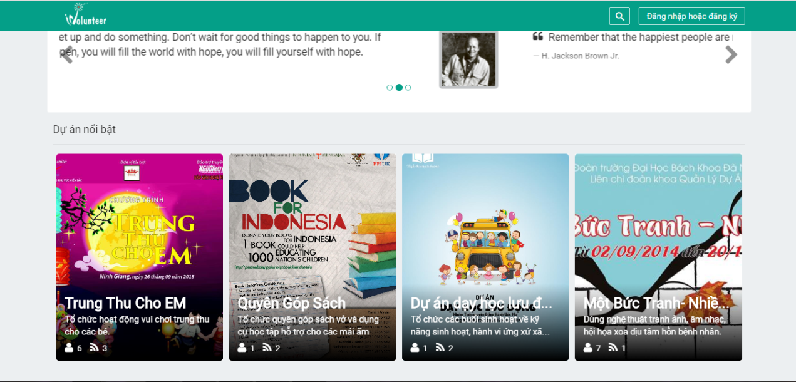

Figure 1: Highlight projects

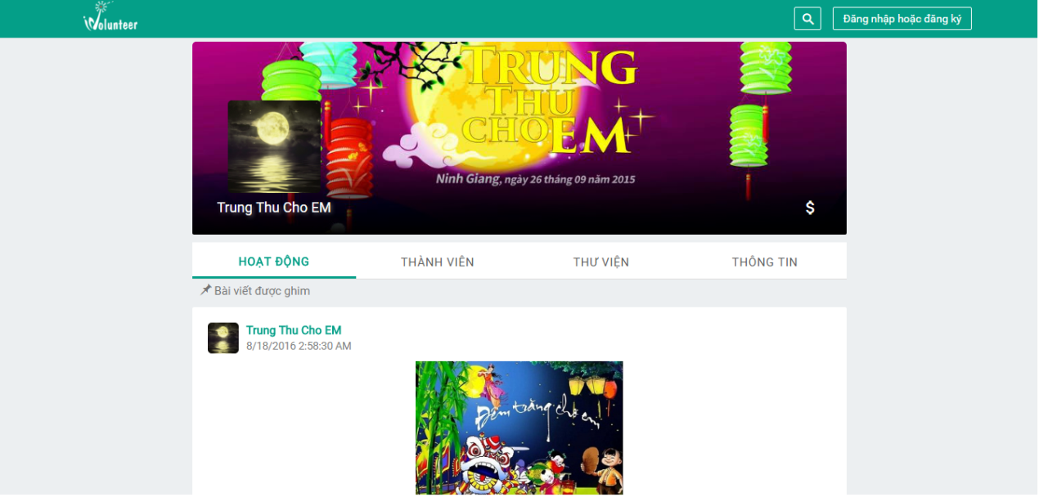

Figure 2: Detail Project

## Donate project

User can donate for highlight projects

**Step** **1**: User click “Tài trợ, quyên góp” icon button.

**Step** **2:** Enter information and click “Gửi” button.

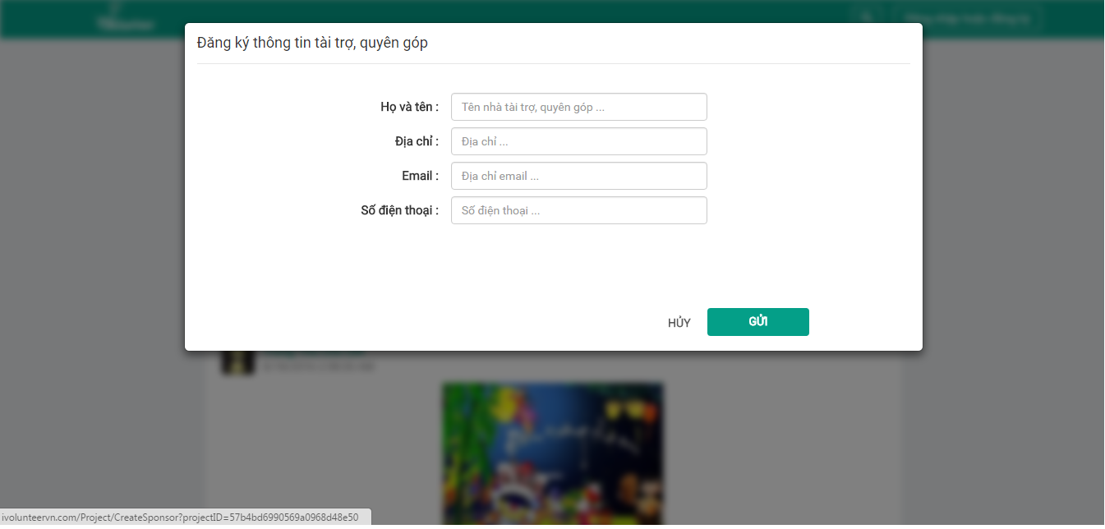

Figure 3: Sponsor registration popup

## Search group, project or registered user

User can search group, project or registered user.

**Step** **1**: Enter keyword into search text box.

**Step** **2**: Click on “Tìm nhóm…”, “Tìm dự án…” or “Tìm thành viên…”.

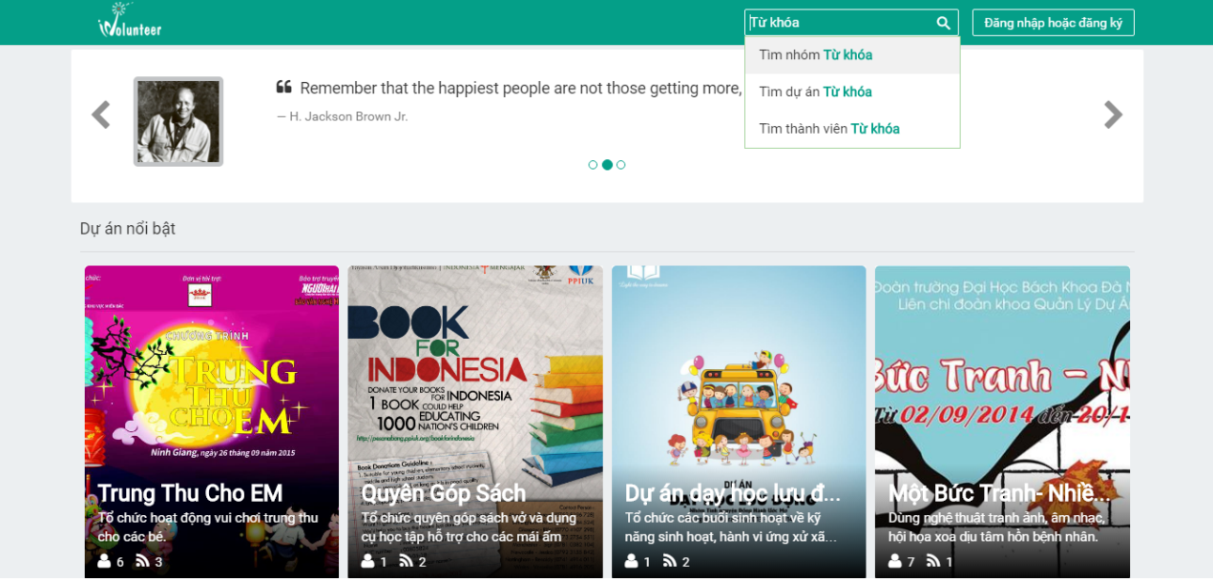

Figure 4: Search by group, project, registered user.

## Advanced search for project.

User can search advanced for project.

**Step 1**: Click on “Tìm dự án …”.The system displays advanced search form.

**Step 2:** Enter information into fields or ticks on checkboxes that user need for Project filter.

**Step 3:** Click “TÌM KIẾM” button.

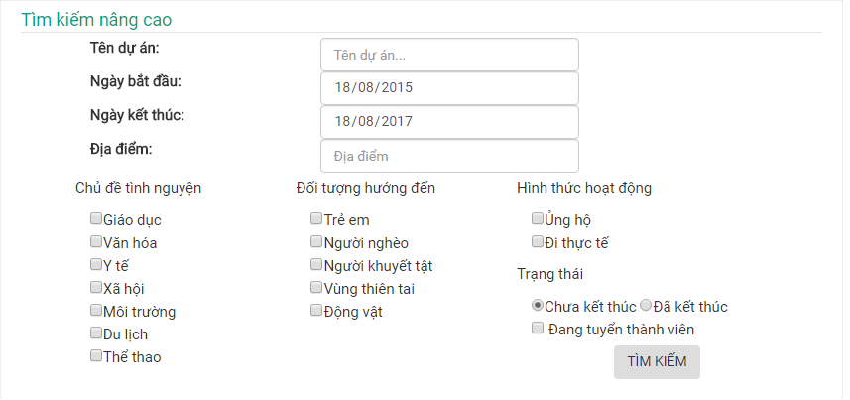

Figure 5: Advanced search screen.

## Register account

**Step 1**: Click on “Đăng nhập hoặc đăng ký” button.

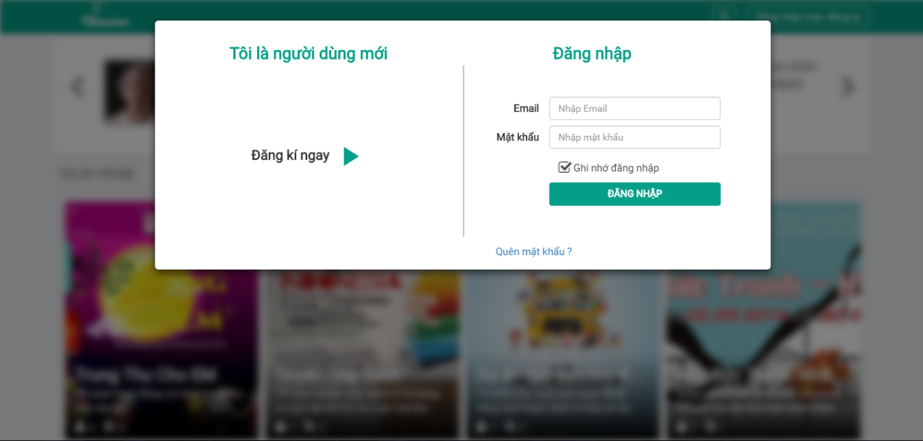

Figure 6:”Đăng nhập hoặc đăng ký” popup

**Step 2**: Click “Đăng ký ngay” icon button.

**Step 3**: Enter information and click “HOÀN TẤT” button.

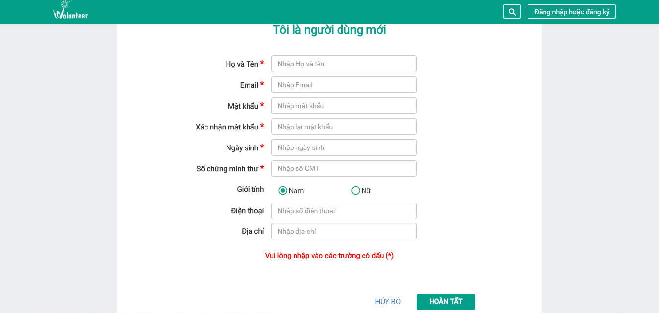

Figure 7: Register account screen.

## Login

**Step 1**: Click on “Đăng nhập hoặc đăng ký” button.

**Step 2**: Enter username and password

**Step 3**: Click “ĐĂNG NHẬP” button.

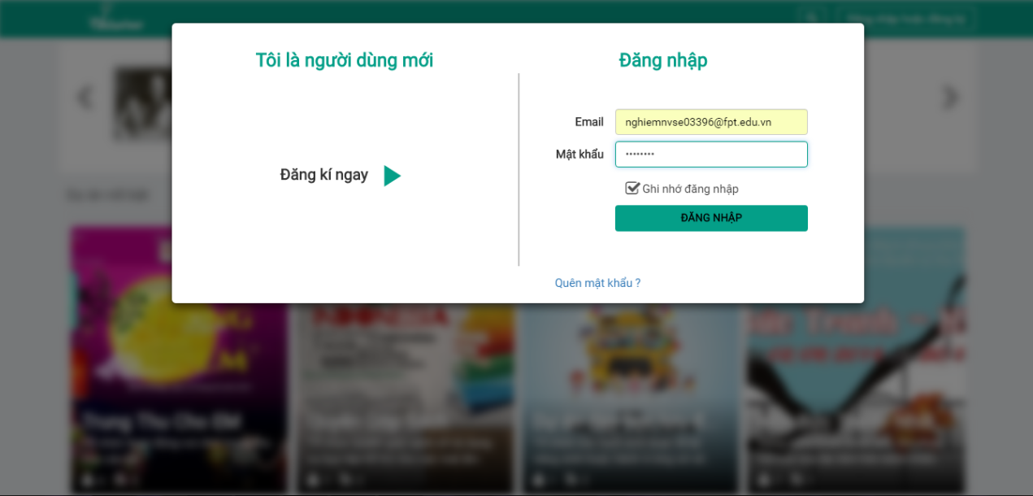

Figure 7: Login

This is the first page which user will see after login to IVSN system

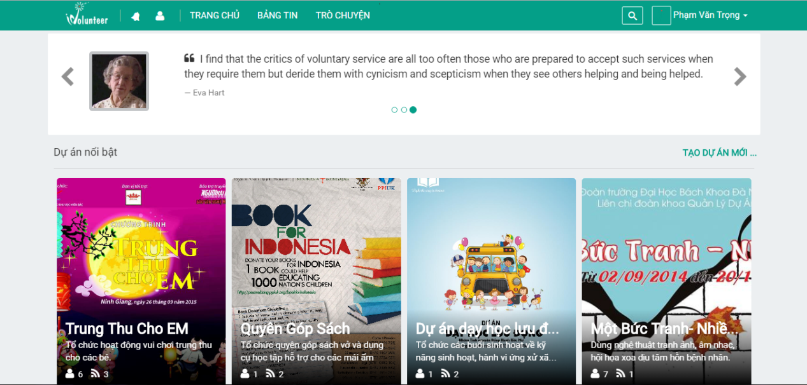

Figure 8: Homepage

## Change personal avatar/cover.

**Step 1:** Click on display name.

**Step 2:** Click “Hồ sơ cá nhân” link to redirect to Personal page.

**Step 3**: Click “Thay đổi ảnh đại diện” button in default avatar (or click “Thay đổi ảnh bìa” button in default cover).

**Step 4**: Select image and click “TẢI LÊN” button.

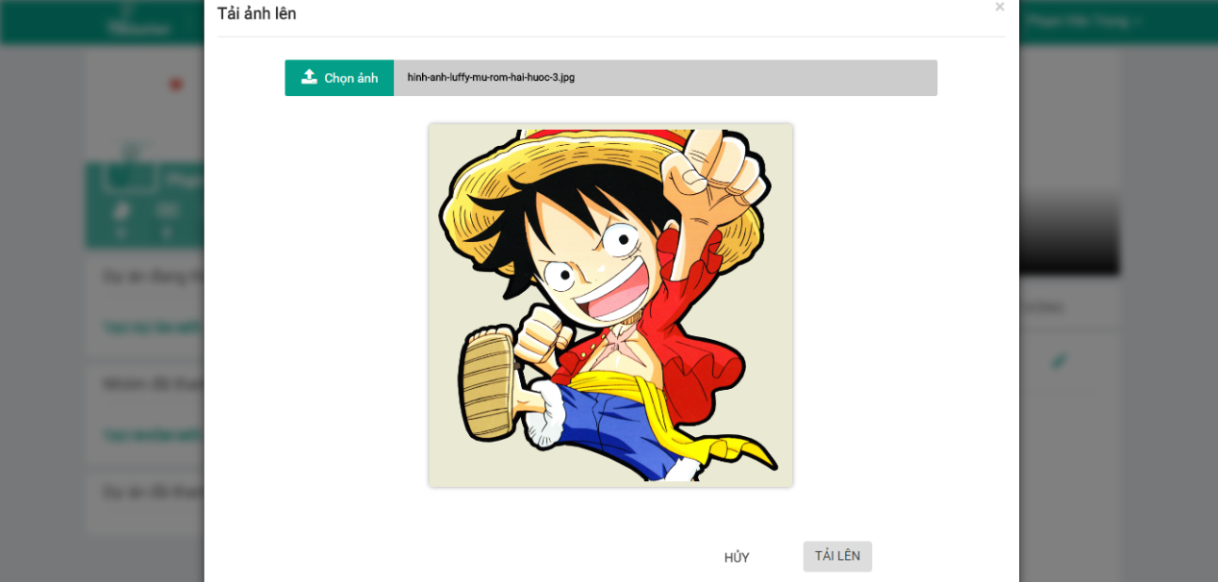

Figure 9: Upload avatar

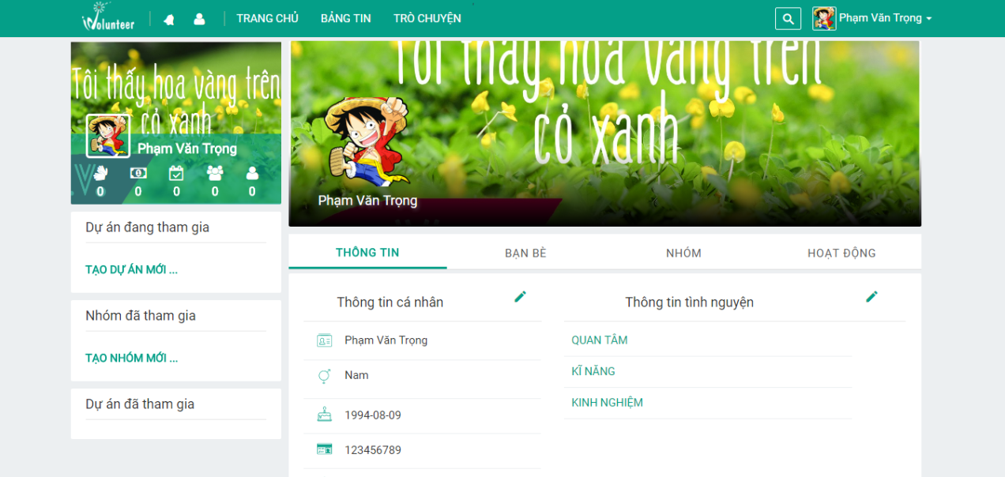

Figure 10: avatar and cover

## Edit profile.

User can change profile.

**Step 1**: Click on the pencil button.

**Step 2**: Fill in form and Click “CẬP NHẬP” button.

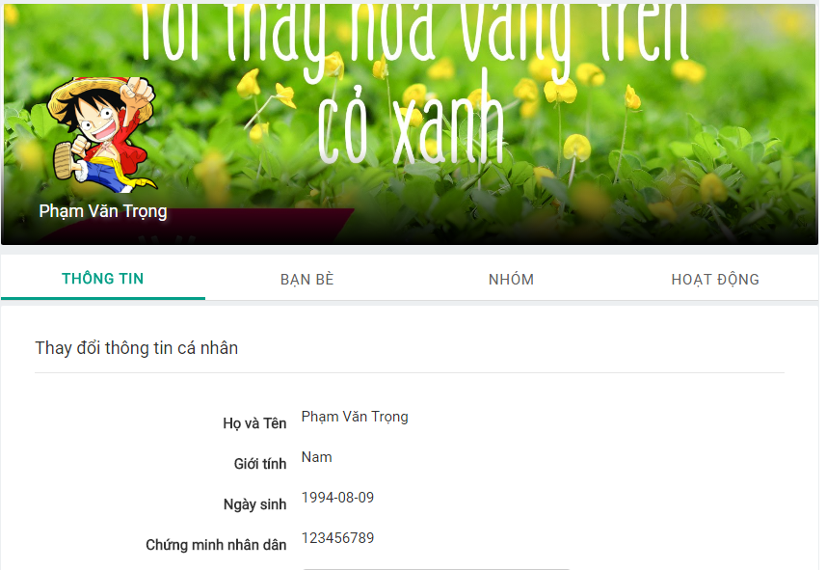

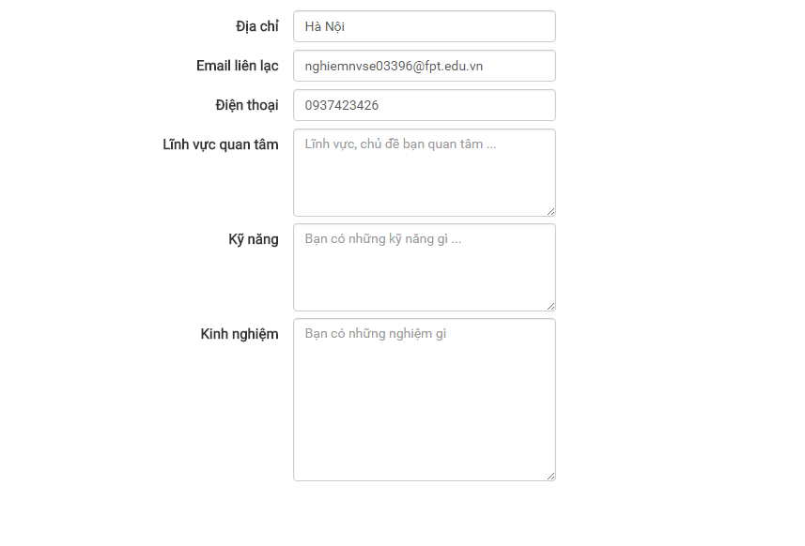



Figure 10: Edit profile

## Friends

Registered user can add friend or unfriend in the system.

**Step 1**: Search other register user in System.

**Step 2**: Click “Kết bạn” icon button. (Waiting for target user agrees)

a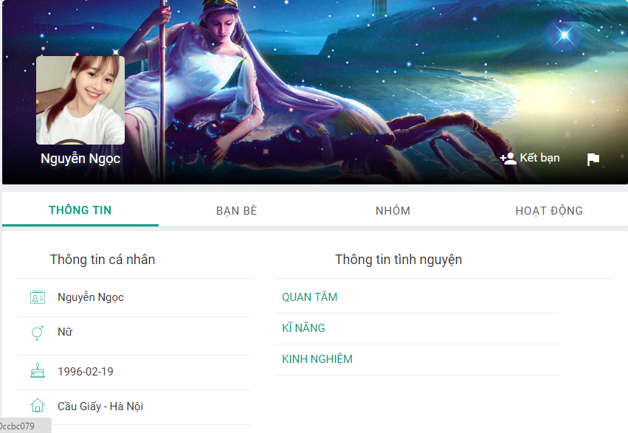

Figure 11: Add Friend.

Registered user can cancel add friend request by clicking on “Hủy yêu cầu kết bạn” button.

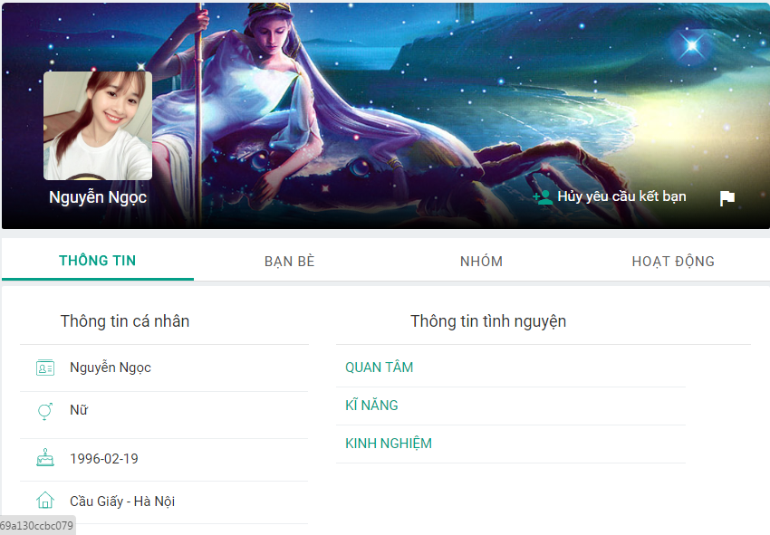

Figure 12: Cancel add friend request.

## Follow project.

Registered user can follow to view updated newest activities of Project.

**Step 1**: Click on a project in the system.

**Step 2**: Click on “Theo dõi” icon button.

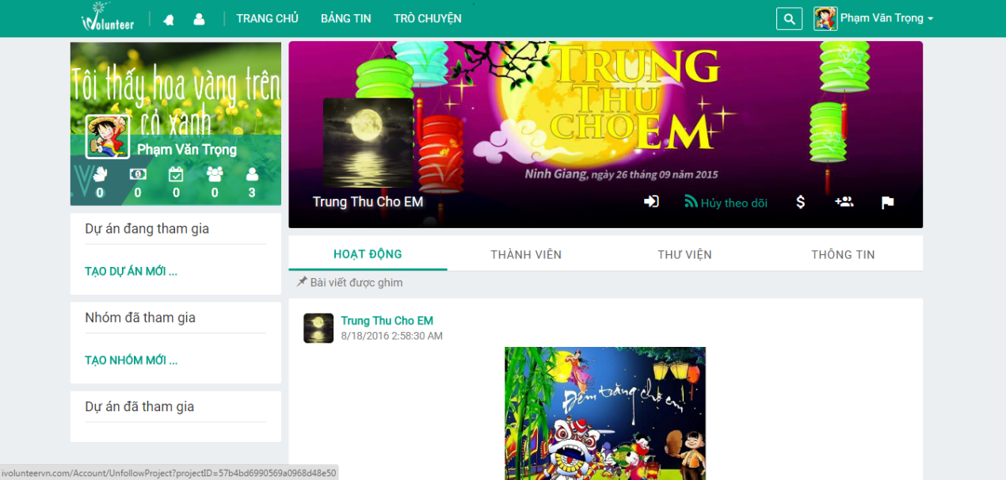

Figure 13: Follow project

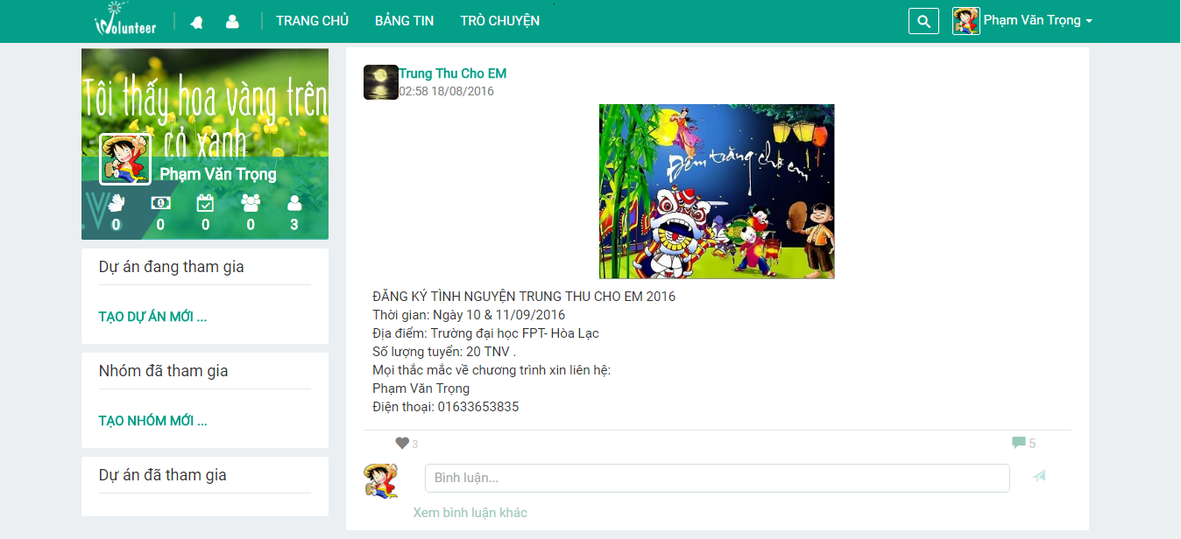

Figure 14: Project activities in Newfeeds

Registered user can unfollow project by clicking on “Hủy theo dõi” button.

## Follow Group

Registered user can follow group to view updated newest activities of group.

**Step 1**: Click on group in the system.

**Step2**: Click “Theo dõi” icon button.

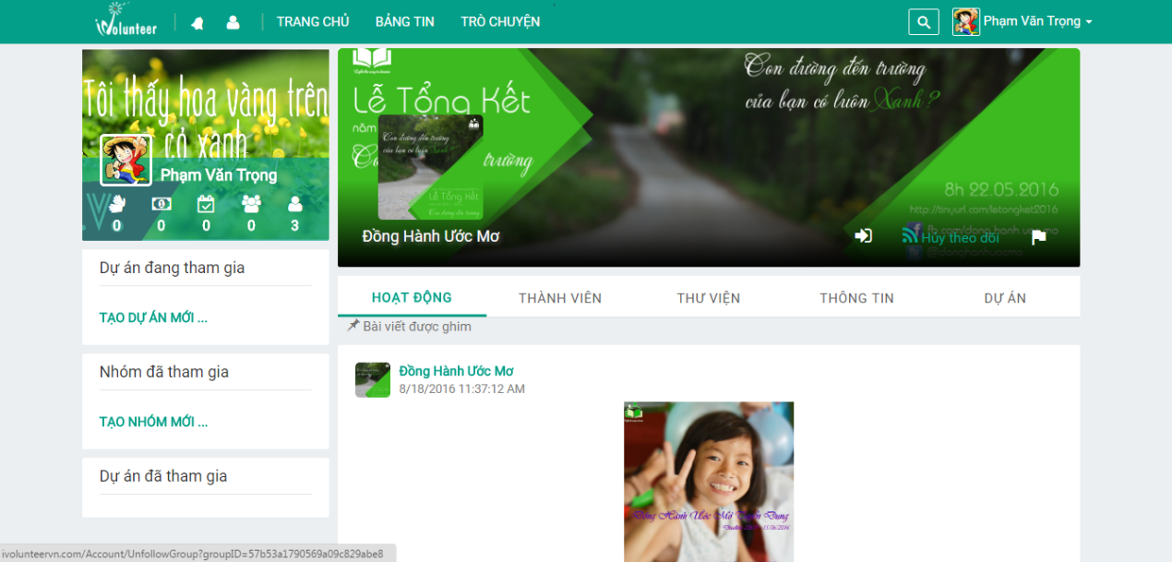

Figure 15: Follow group.

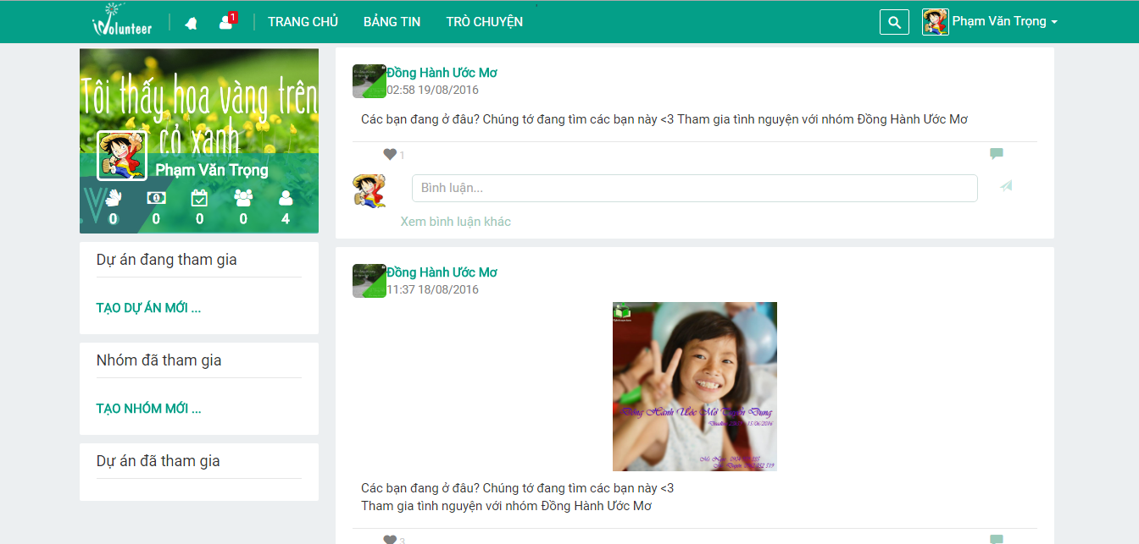

Figure 16: Group activities in Newfeeds

Registered user can unfollow group by clicking on “Hủy theo dõi” button.

## Join Project

Registered user can join project

**Step 1**: Click on project in system

**Step 2**: Click “Tham gia” icon button. (Waiting for project leader agrees and become member of project).

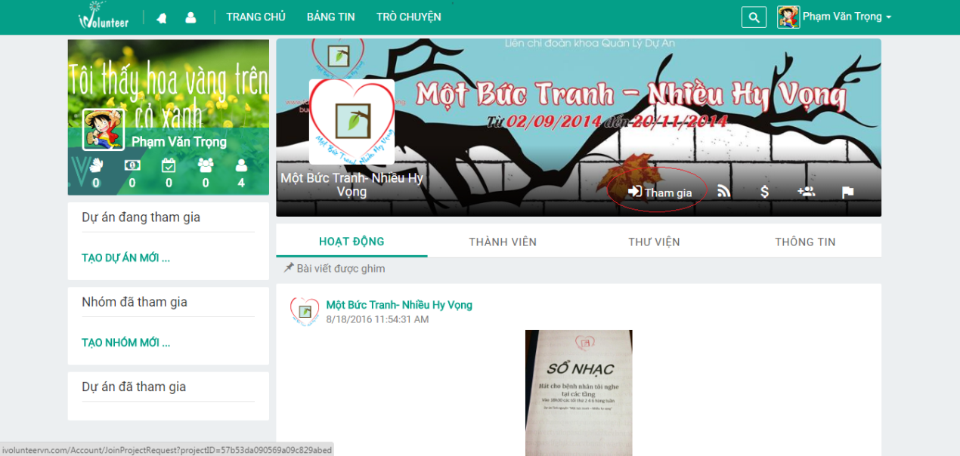

Figure 17: Join Project

Registered user can cancel join project request by clicking on “Hủy yêu cầu tham gia” button.

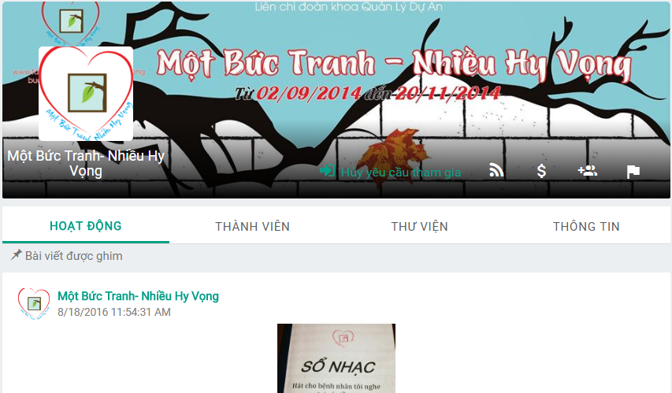

Figure 18: Cancel join project

## Join group

Registered user can join group in the system

**Step 1**: Click on group in the system.

**Step 2**: Click “Tham gia” icon button (waiting for group leader agrees and become member of project).

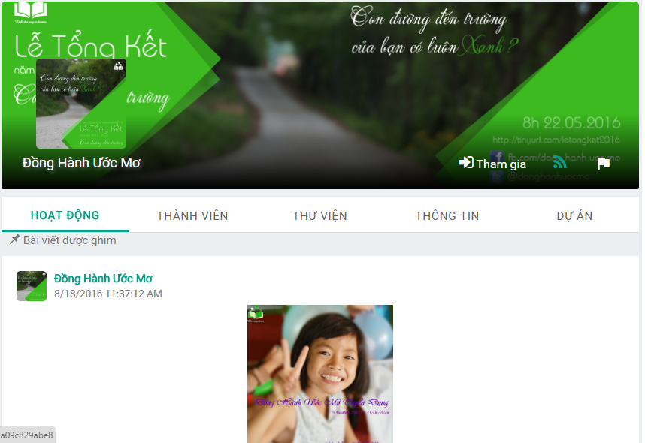

Figure 19: Join group

Registered user can cancel join group request by clicking on “Hủy yêu cầu tham gia” button.

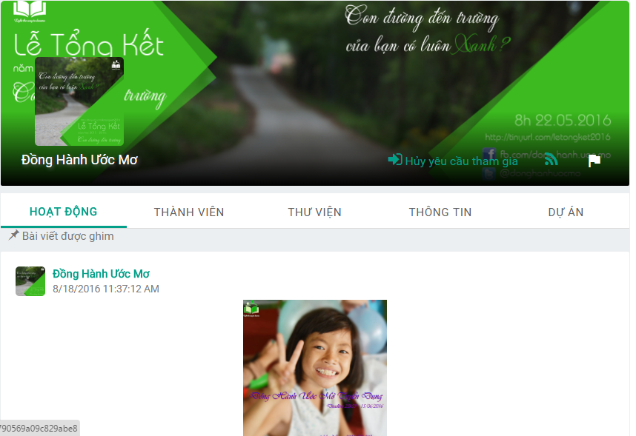

Figure 20:Cancel join group

## Donate for project

Registered user can donate for project.

**Step 1**: Click on project in the system.

**Step 2**: Click “Ủng hộ” icon button.

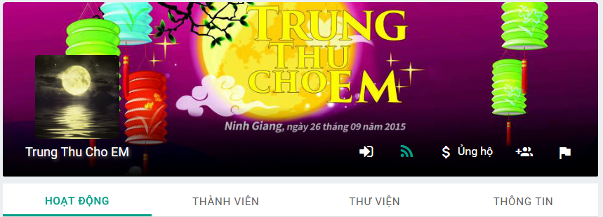

Figure 21: Send Donation request

Register user can cancel donation request by clicking on “Hủy yêu cầu ủng hộ” button.

Figure 21: Cancel donation request

## Join Project invitation

When registered user receives join project invitation, registered user can accept or deny invitation.

**Step 1**: Click on display name.

**Step 2**: Click on “LỜI MỜI THAM GIA” tab in profile page.

**Step 3**: Click on “Đồng ý” icon button or “Từ chối” icon button.

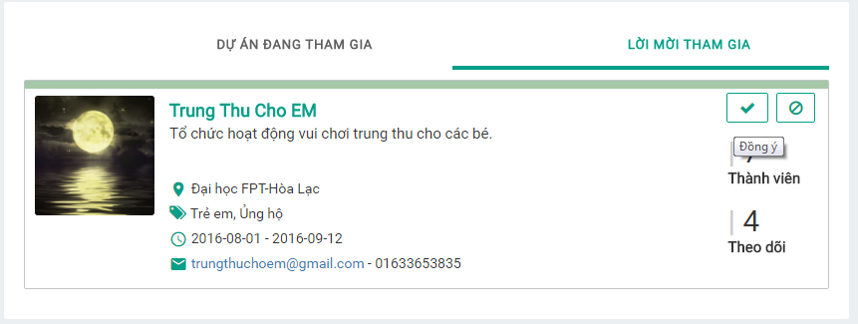

Figure 22: Accept invitation.

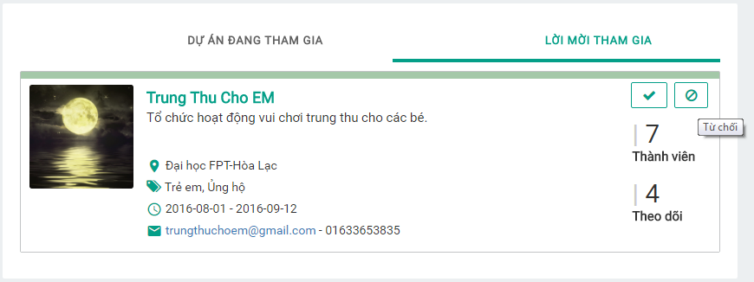

Figure 22: Deny invitation.

## Suggest friend to join project.

Member can suggest friend to project leader to join project.

**Step 1**: Click on “THÀNH VIÊN” tab in project.

**Step 2**: Click on “THÀNH VIÊN” tab.

**Step 3**: Click on “Đề xuất bạn bè” button. The system displays member’s friend list.

**Step 4**: Click “XÁC NHẬN” button.

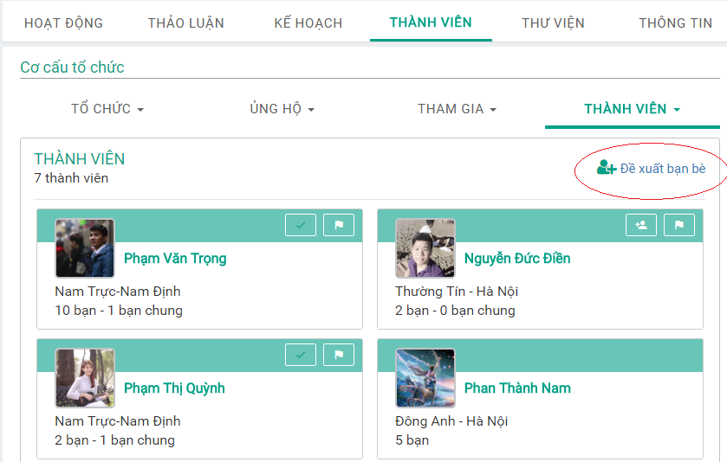

Figure 23: Suggest friend

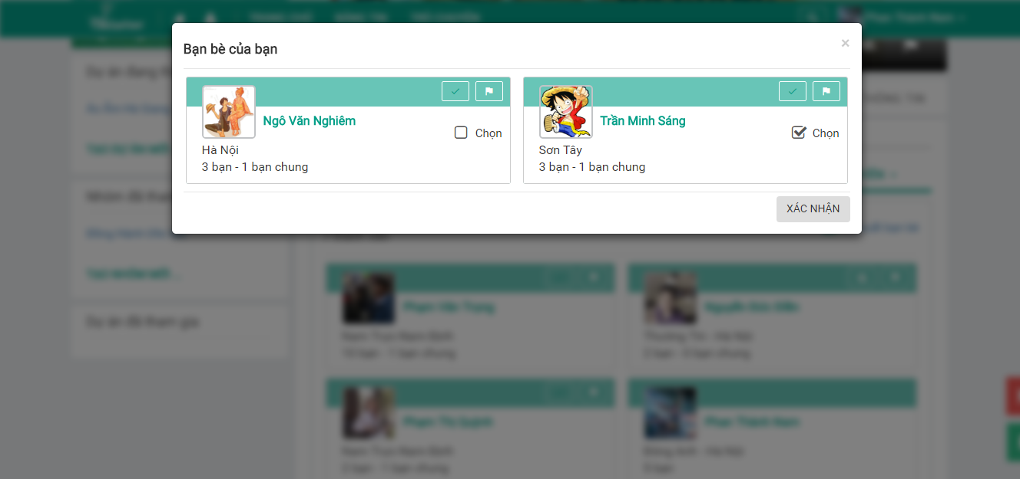

Figure 24: Friend list

## Create project.

Registered user can create project.

**Step 1**: Click “TẠO DỰ ÁN MỚI” link. The system displays Project registration popup.

**Step 2**: Enter information and Click “TẠO” button.

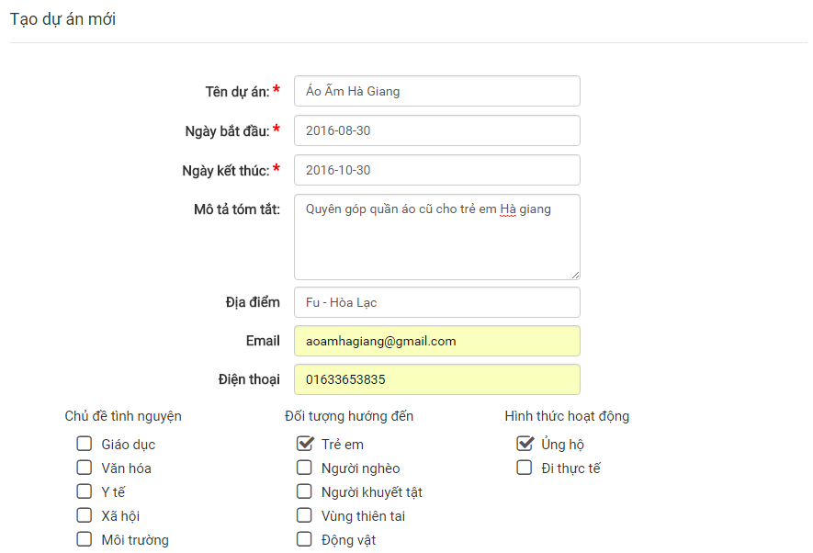

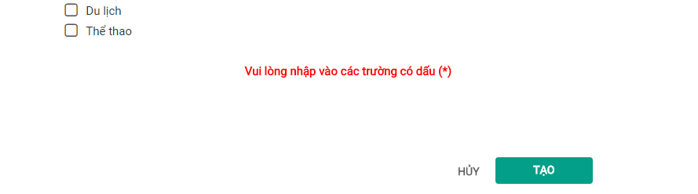

Figure 25: Create project.

## Edit project information.

When registered user is project leader, can edit project information.

**Step 1**: Click on “THÔNG TIN” tab in Project.

**Step 2**: Click on pencil button.

**Step 3**: Fill in form and Click “CẬP NHẬP” button.

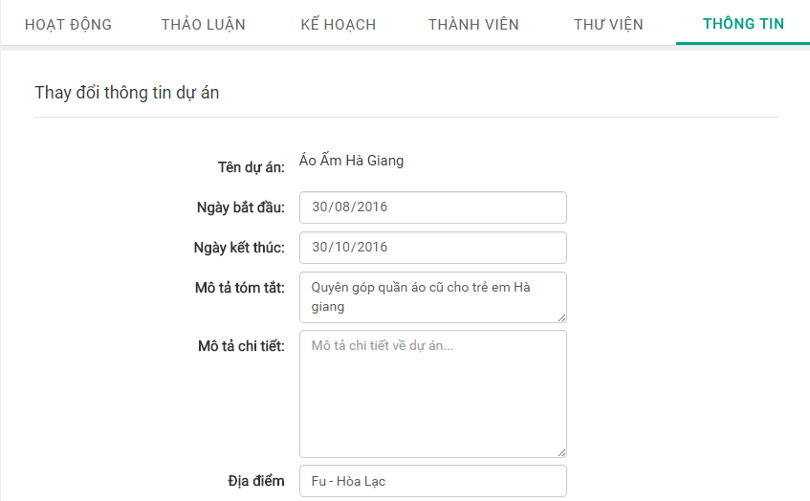

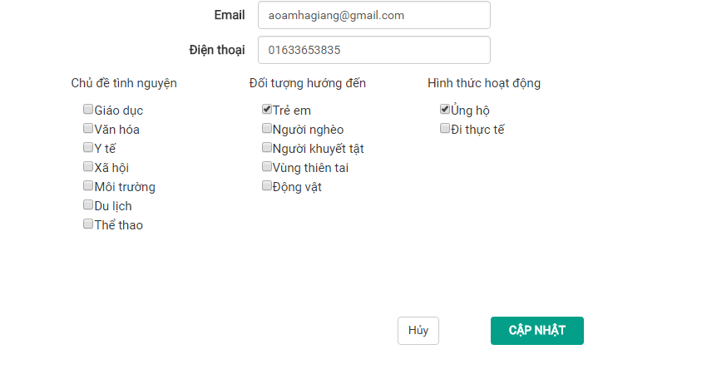

Figure 26: Edit project information.

## User join project request

When Project leader receives request asking for joining the project from a registered user, Project leader can accept or deny request.

**Step 1**: Click on “THÀNH VIÊN” tab in project.

**Step 2**: Click on “CÁ NHÂN MUỐN THAM GIA” tab.

**Step 3**: Click on “Đồng ý” icon button or “Từ chối” icon button.

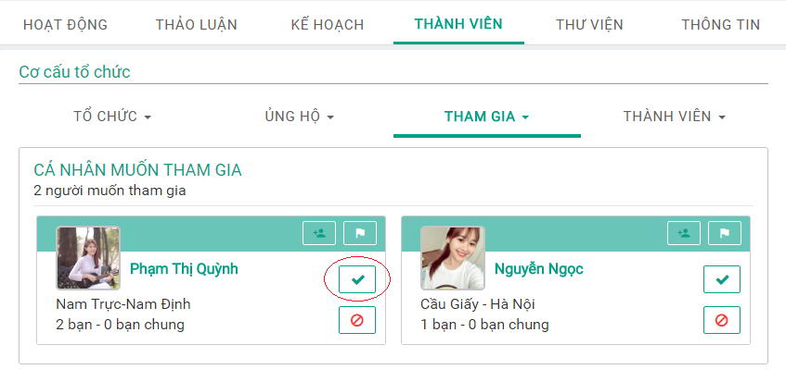

Figure 27: Accept request.

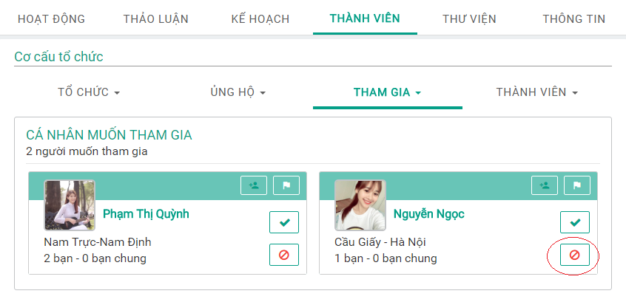

Figure 28: Deny request.

## Group join project request.

When Project leader receives request asking for joining the project from a group, Project leader can accept or deny request

**Step 1**: Click on “THÀNH VIÊN” tab.

**Step 2**: Click “NHÓM MUỐN THAM GIA” tab.

**Step 3**: Click on “Đồng ý” icon or “Từ chối” icon button.

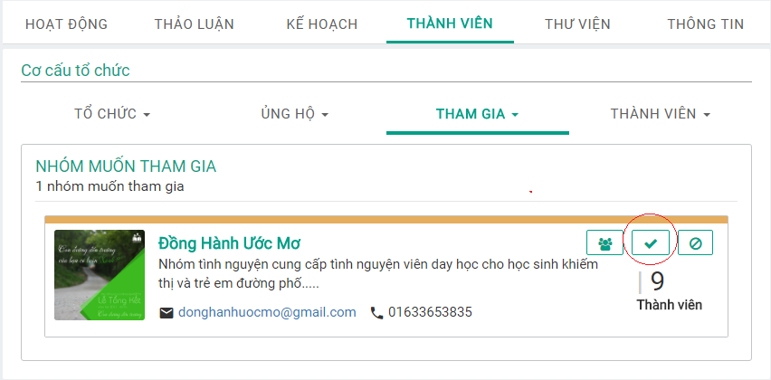

Figure 29: Accept group request.

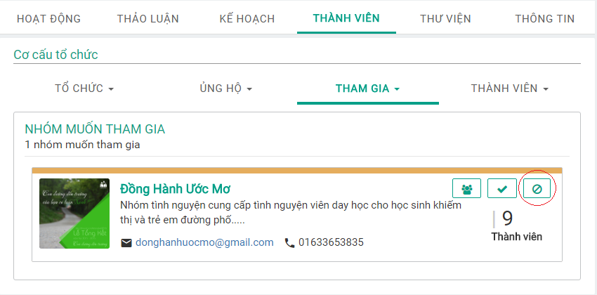

Figure 30: Deny group request.

## Individual donation request

When project leader receives request asking for donation to the project from a registered user, Project leader can accept or deny request

**Step 1**: Click on “THÀNH VIÊN” tab.

**Step 2**: Click on “CÁ NHÂN MUỐN ỦNG HỘ” tab.

**Step 3**: Click on “Đồng ý” icon button or “Từ Chối” icon button.

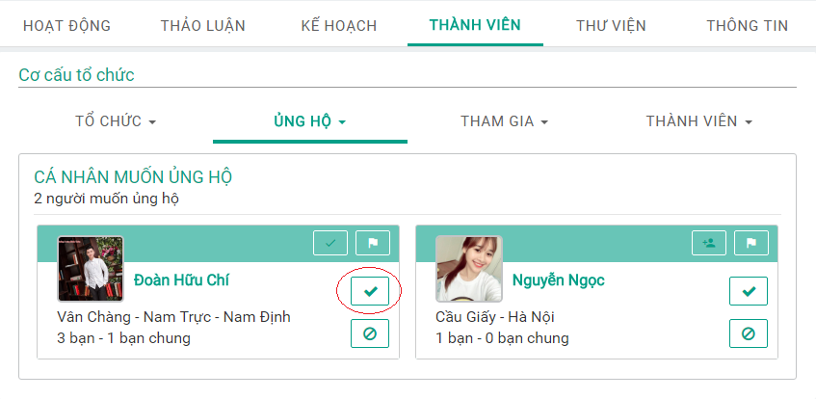

Figure 31: Accept donation request.

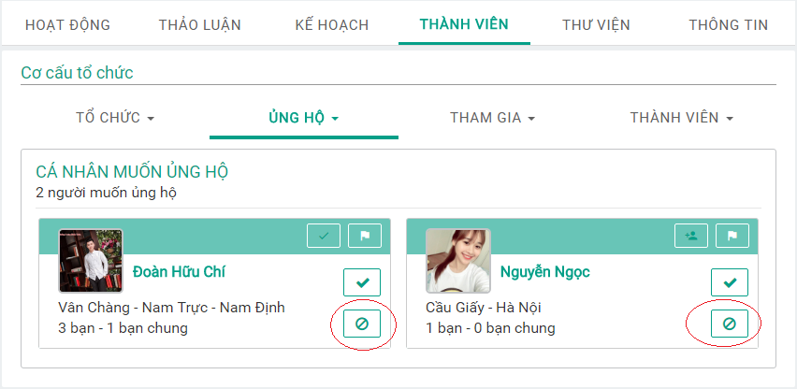

Figure 32: Deny donation request.

## Group donation request.

When project leader receives request asking for donation to the project from a group, Project leader can accept or deny request

**Step 1**: Click on “THÀNH VIÊN” tab.

**Step 2**: Click on “NHÓM MUỐN ỦNG HỘ” tab.

**Step 3**: Click on “Đồng ý” icon button or “Từ Chối” icon button.

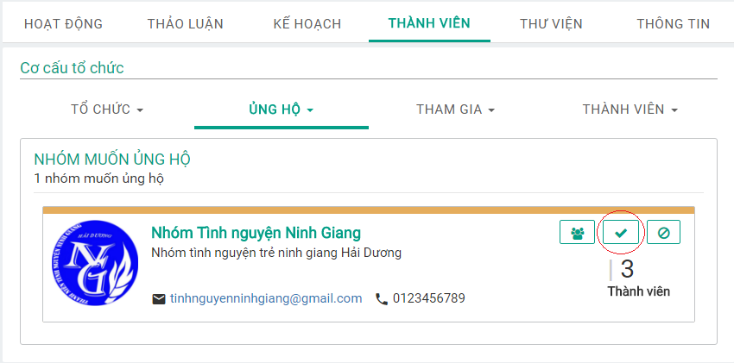

Figure 33: Accept group donation request.

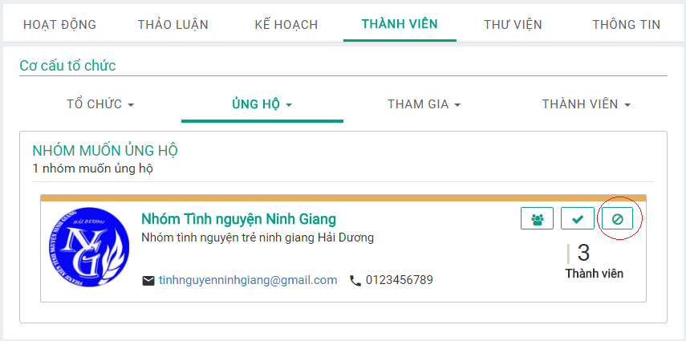

Figure 34: Deny group donation request.

## Guest donation request.

When project leader receives request asking for donation to the project from guest, Project leader can accept or deny request

**Step 1**: Click on “THÀNH VIÊN” tab.

**Step 2**: Click on “NGƯỜI NGOÀI MUỐN ỦNG HỘ” tab.

**Step 3**: Click on “Đồng ý” icon button or “Từ Chối” icon button.

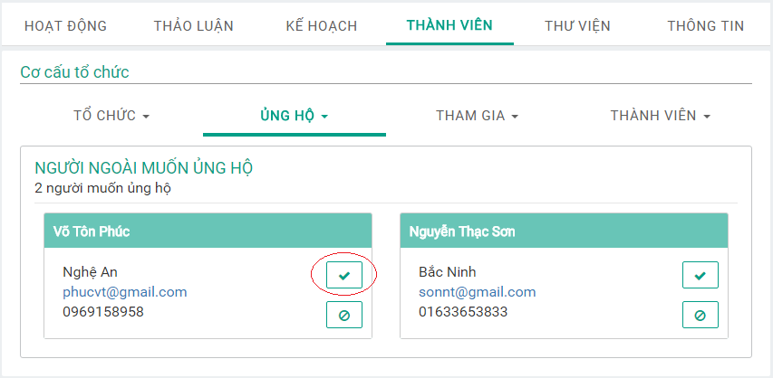

Figure 35: Accept guest donation request.

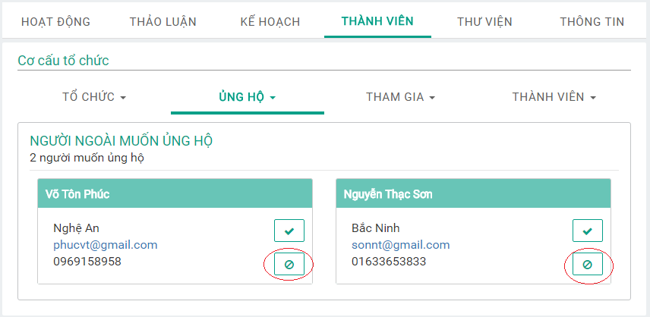

Figure 36: Deny guest donation request.

## Add organized user.

Project leader can add member to be organized user.

**Step 1**: Click “THÀNH VIÊN” tab.

**Step 2**: Click “CÁ NHÂN TỔ CHỨC” tab.

**Step 3**: Click “Thêm thành viên” button. The system displays a popup that allows project leader to select members.

**Step 4**: Click “HOÀN THÀNH” button.

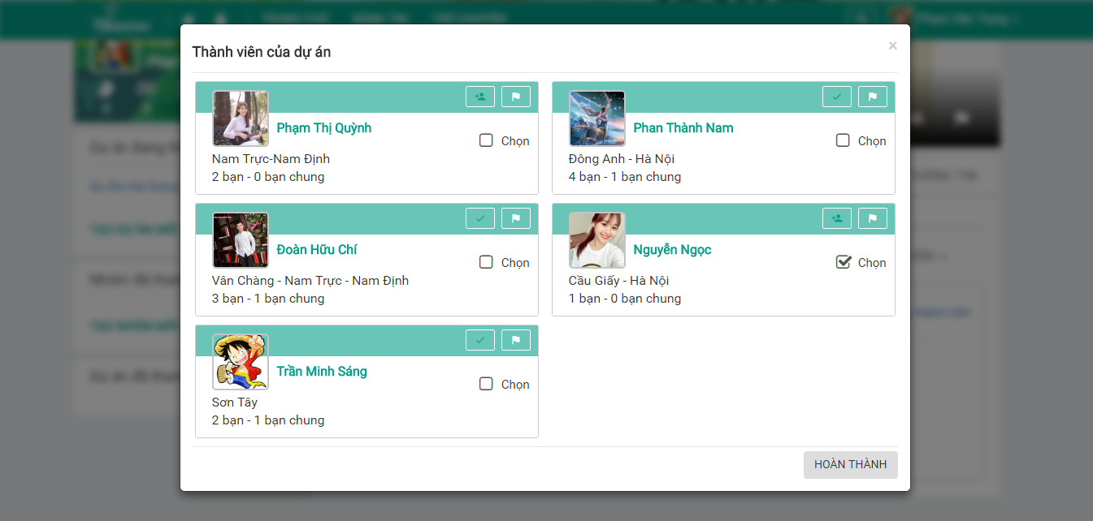

Figure 37: Members of project.

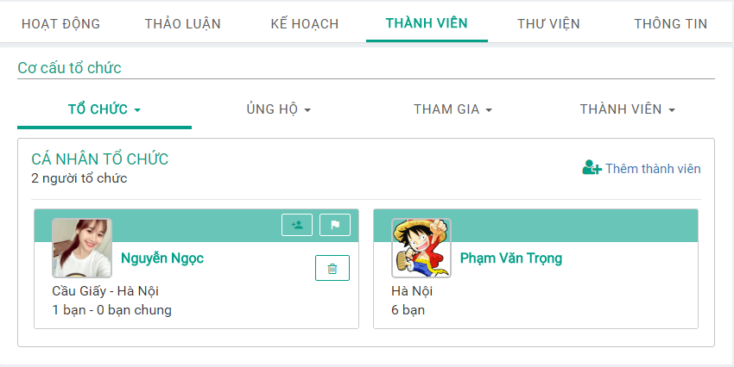

Figure 38: Organized user.

Project leader can remove an organized user by clicking on “Xóa” button icon.

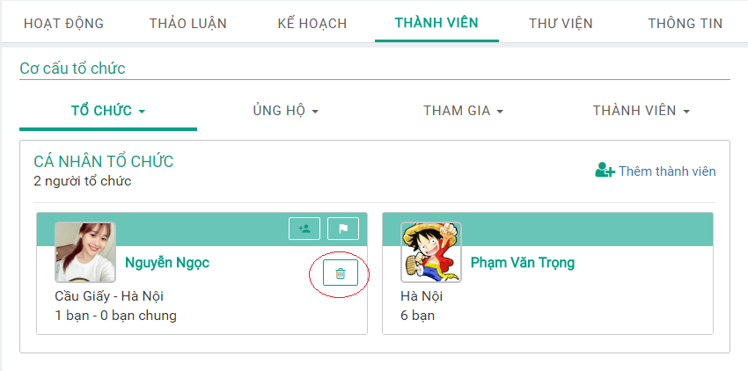

Figure 39: Remove Organized user.

## Add organized group.

Project leader can add member to be organized user.

**Step 1**: Click on “THÀNH VIÊN” tab.

**Step 2**: Click on “NHÓM TỔ CHỨC” tab.

**Step 3**: Click on “Thêm nhóm” button. The system displays a popup that allows project leader to select joined group.

**Step 4**: Click on “XÁC NHẬN” button.

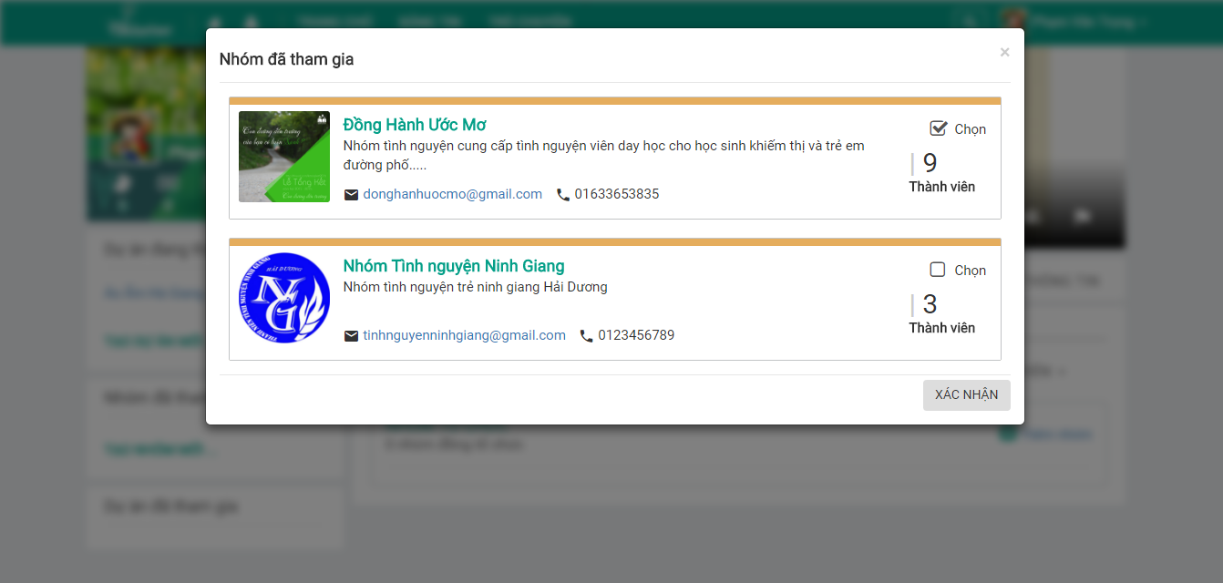

Figure 40: Joined group popup.

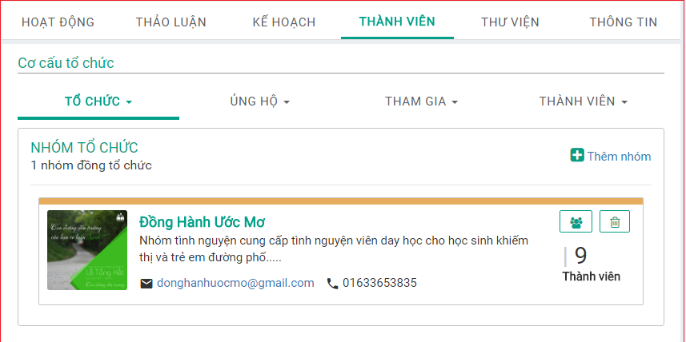

Figure 41: Organized group.

Project leader can remove an organized group by clicking on “Xóa” icon button.

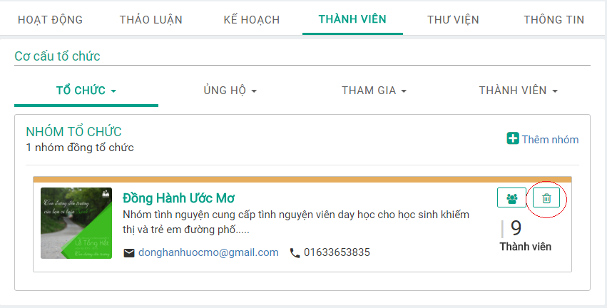

Figure 42: Remove Organized group.

## Invite friend to project

Project Leader can invite friends to project.

**Step 1**: Click “THÀNH VIÊN” tab in project.

**Step 2**: Click “THÀNH VIÊN” tab.

**Step 3**: Click “Mời bạn bè” button. The system displays project leader’s friend list popup.

**Step 4**: Click “XÁC NHẬN” button.

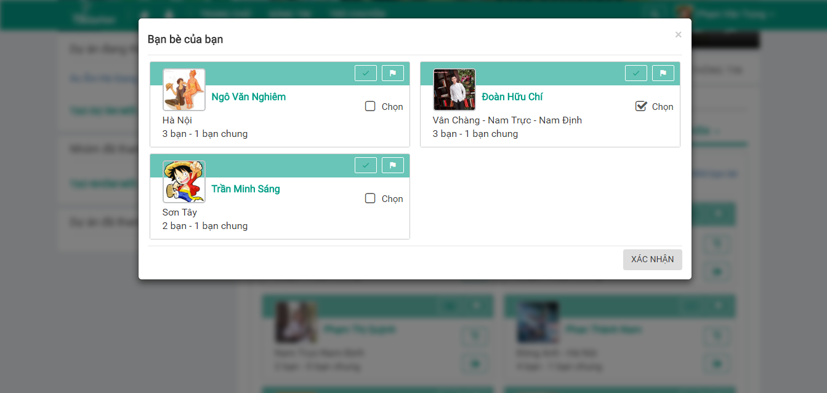

Figure 43:invite friend.

## Suggest friend to join project from member

When Project leader receives request suggesting friend for joining the project from member, Project leader can accept or deny request.

**Step 1**: Click on “THÀNH VIÊN” tab.

**Step 2**: Click “CÁ NHÂN ĐƯỢC ĐỀ XUẤT” tab.

**Step 3**: Click “Đồng ý” icon button or “Từ chối” icon button.

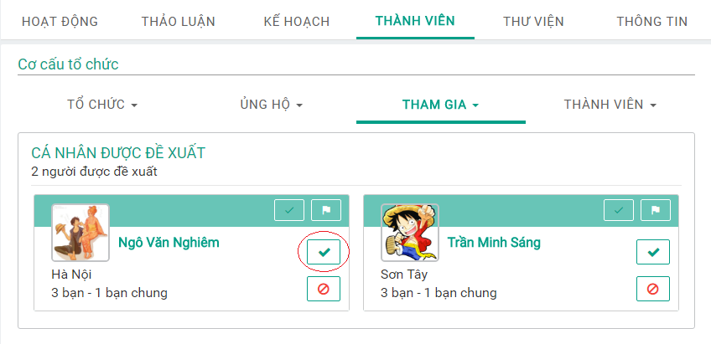

Figure 44: Accept suggestion.

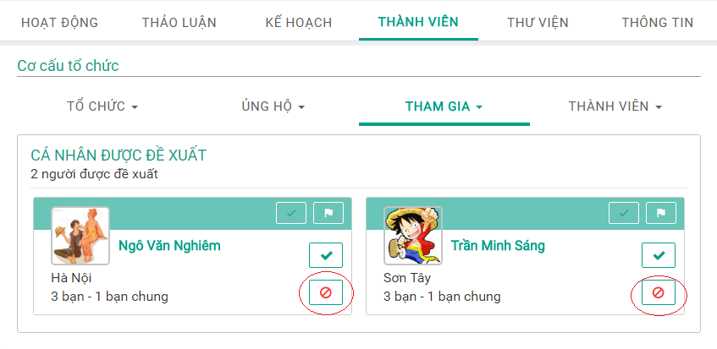

Figure 45: Deny suggestion.

## Assign/Degrade Project leader.

Project leader can promote a member becoming leader.

**Step 1**: Click on “THÀNH VIÊN” tab.

**Step 2**: Click on “Thăng chức” icon button.

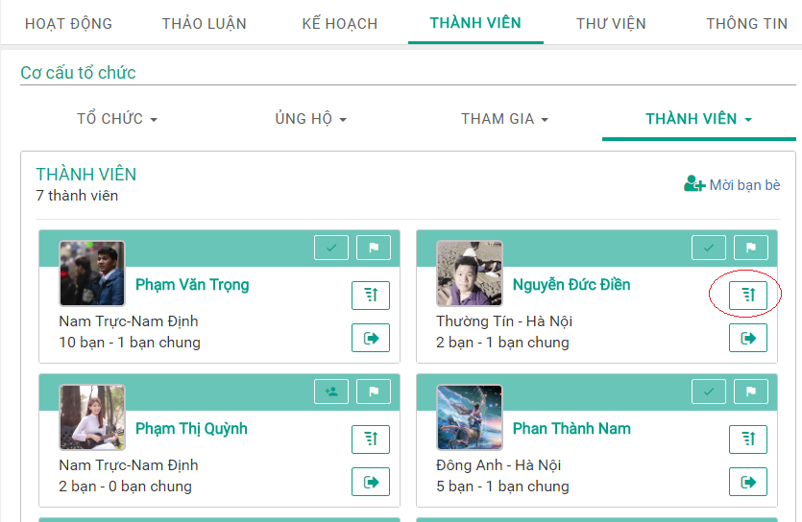

Figure 46: Promote leader.

Project leader can degrade leader.

**Step 1**: Click on “THÀNH VIÊN” tab.

**Step 2**: Click on “TRƯỞNG DỰ ÁN” tab.

**Step 3**: Click on “Giáng chức” icon button.

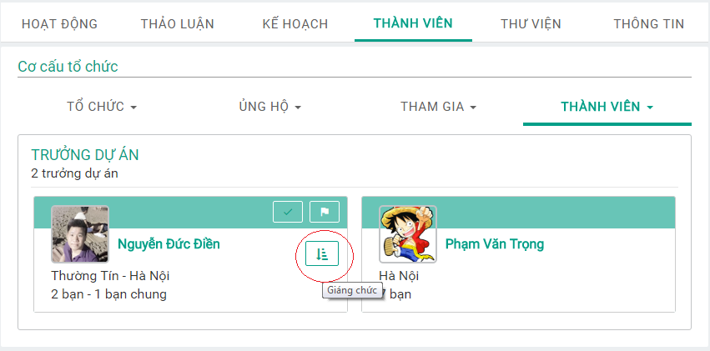

Figure 47: Degrade leader.

## Remove member from project.

Project leader can remove member (for example: members that lack of enthusiasm…)

**Step 1**: Click “THÀNH VIÊN” tab.

**Step 2**: Click “Trục xuất” icon button.

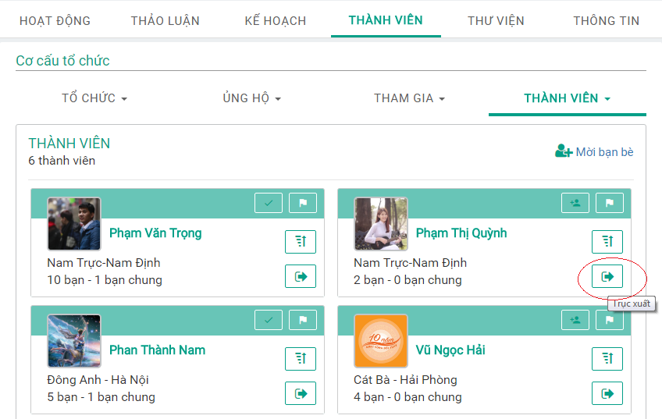

Figure 48: Remove member.

## Create deployment plan.

Project leader can create deployment plan for project. (For example: “Trung Thu Cho Em” project)

**Step 1**: Click on “KẾ HOẠCH” tab.

**Step 2:** Click on “KẾ HOẠCH TRIỂN KHAI” tab.

**Step 3:** Click on “THÊM GIAI ĐOẠN” link. “Thêm giai đoạn” form is displayed.

**Step 4:** Fill in form and click on “THÊM” button.

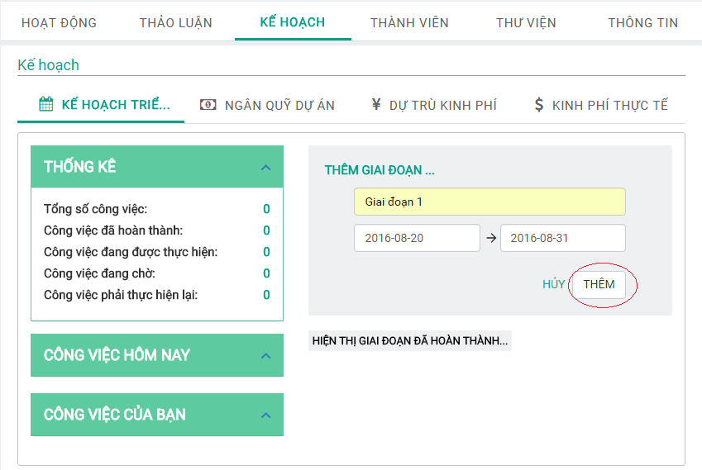

Figure 49: Add phase.

Next, Project leader can add work of phase.

**Step 1**: Click on “THÊM CÔNG VIỆC” link in phase. “Thêm công việc” form is displayed.

**Step 2**: Fill in form and click on “THÊM” button.

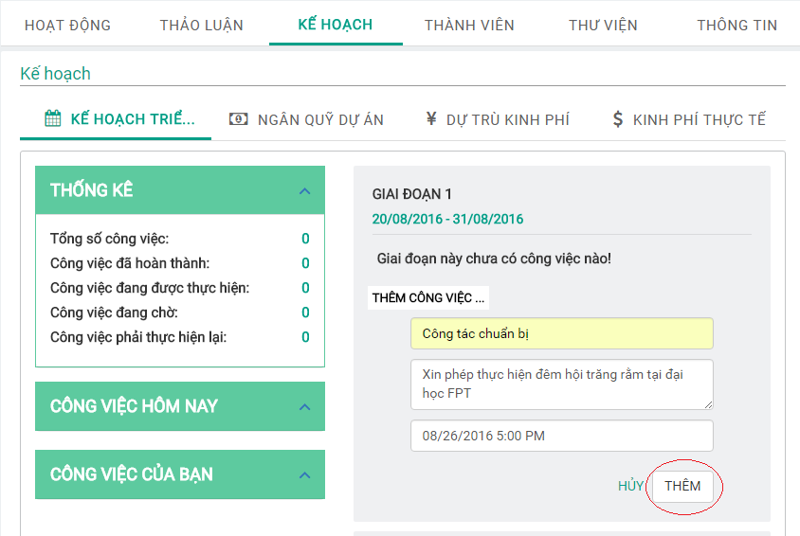

Figure 49: Add work of phase.

Project leader can assign work to members by clicking on “work’s name” link.

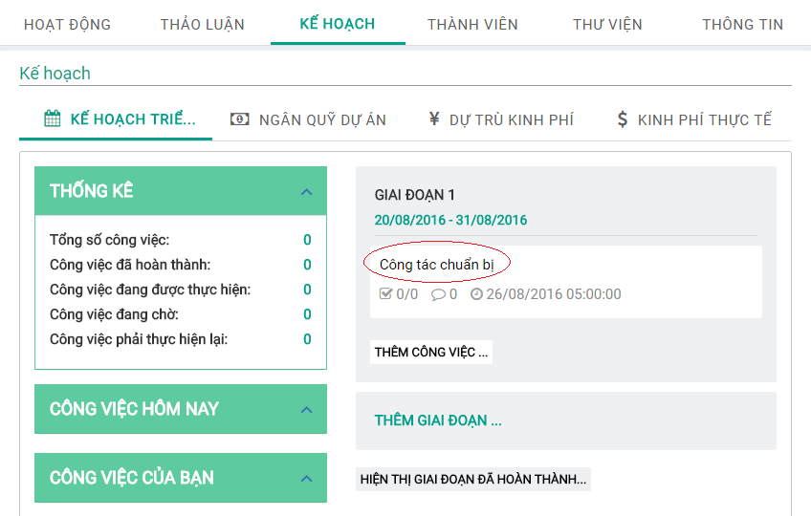

Figure 50: work’s name link

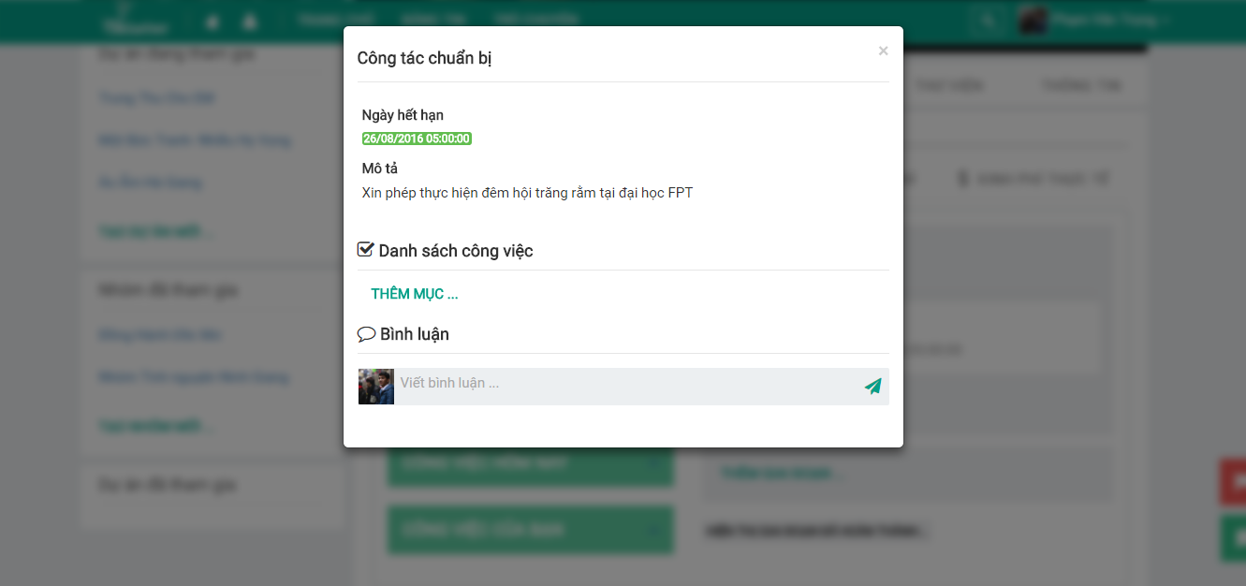

Figure 51: work popup.

Project leader assign work to each member.

**Step 1**: Click on “THÊM MỤC” link.

**Step 2**: Fill in form and Click on “THÊM” button.

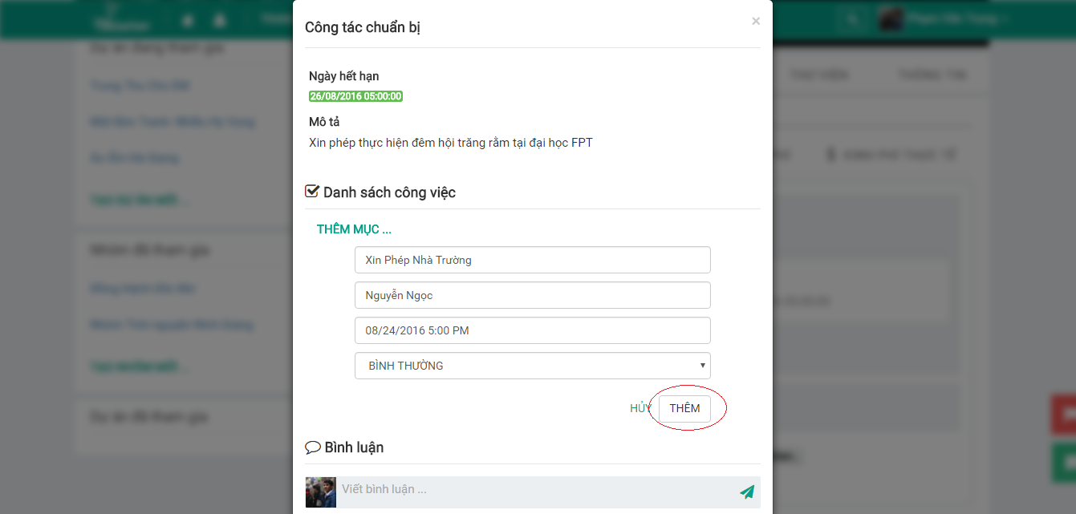

Figure 52: Assign work to member.

After assign, Project leader will wait to member receives the work. And can comment about work.

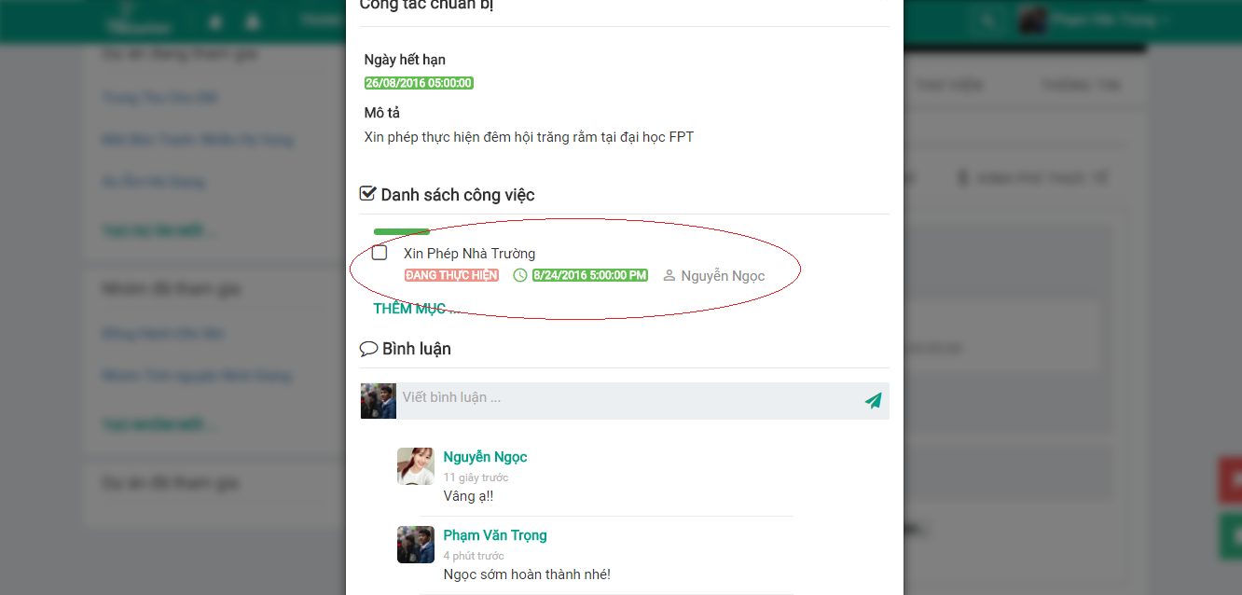

Figure 53: Comment about work.

When the work is completed, project leader can finish by clicking on check box.

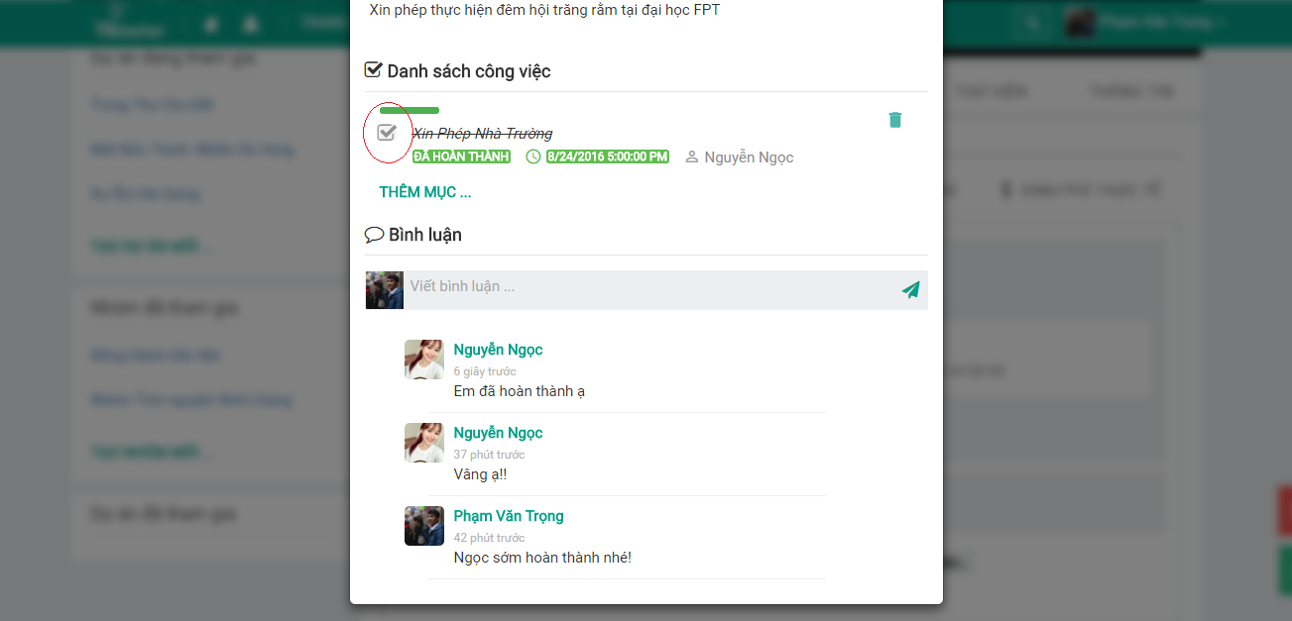

Figure 54: Finish work

## Create budget of project.

Project leader can create budget of project.

**Step 1**: Click on “KẾ HOẠC” tab.

**Step 2**: Click on “NGÂN QUỸ DỰ ÁN” tab.

**Step 3**: Click on “THÊM NỘI DUNG” link. “Thêm nội dung” form is displayed.

**Step 4**: Click “THÊM” button.

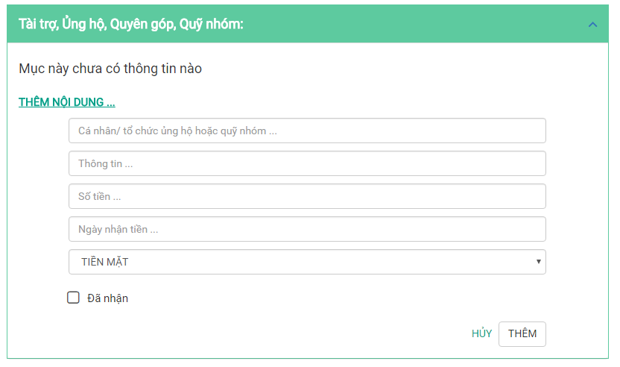

Figure 55: add content form

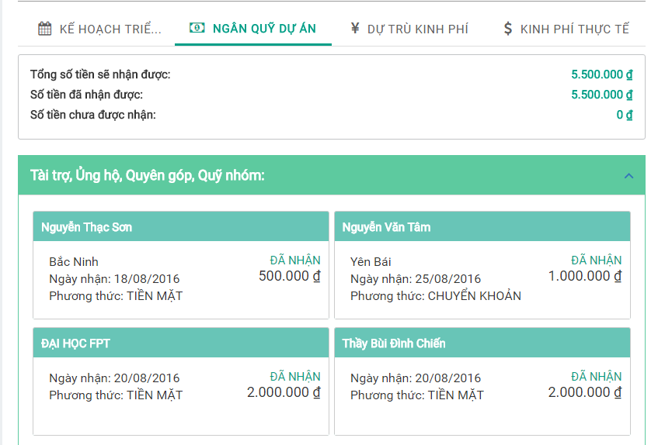

Figure 56: budget

## Estimated budget

Project leader can create estimated budget for project.

**Step 1**: Click on “KẾ HOẠCH” tab.

**Step 2**: Click on “DỰ TRÙ KINH PHÍ” tab.

**Step 3**: Click on “THÊM ĐẦU MỤC” button.

**Step 4**: Fill in form and click on “THÊM” button.

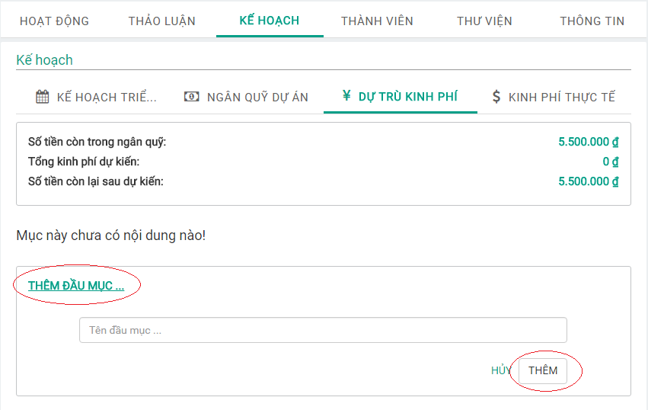

Figure 57: “Thêm đầu mục” form

**Step 5**: Click “THÊM NỘI DUNG” link

**Step 6**: Fill in form and Click “THÊM” button.

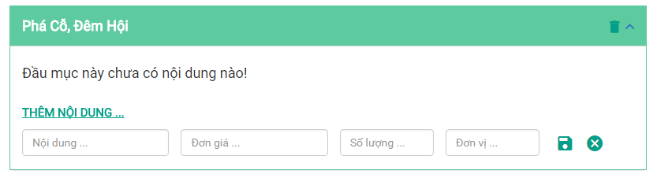

Figure 58: “Thêm nội dung” form

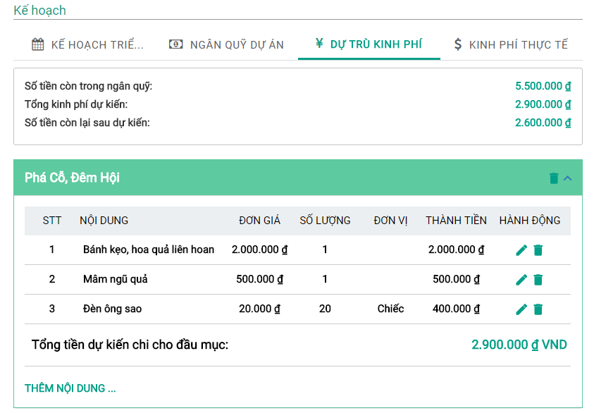

Figure 59: Estimated budget

## Funding for real

Project leader can create funding for real of project.

**Step 1:** Click on “KẾ HOẠCH” tab.

**Step 2**: Click on “KINH PHÍ THỰC TẾ” tab.

**Step 3**: Click on “THÊM HOẠT ĐỘNG” link.

**Step 4**: Fill in form and Click on “THÊM” button.

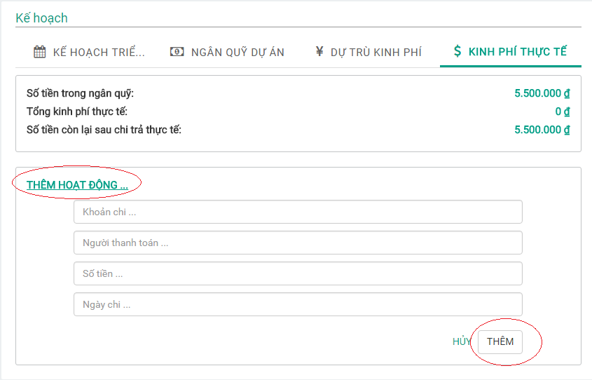

Figure 60: “Thêm hoạt động” form.

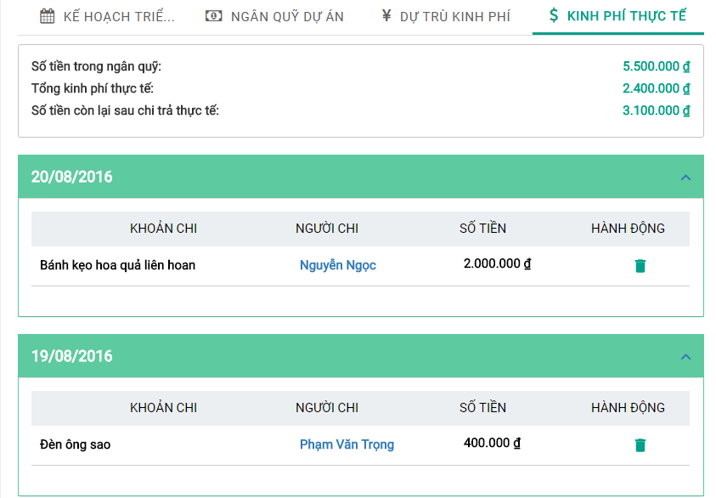

Figure 61: Funding for real

## Create group

Registered user can create group in the system.

**Step 1**: Click “TẠO NHÓM MỚI. The system displays group creation popup.

**Step 2**: Fill in form and click “TẠO” button.

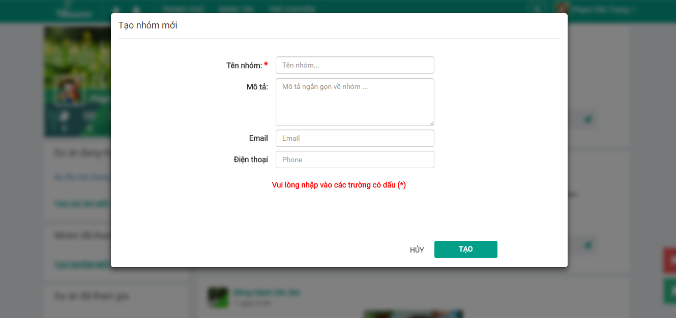

Figure 62: Create group.

## Edit group information.

When registered user is project leader, can edit project information.

**Step 1**: Click on “THÔNG TIN” tab in Group.

**Step 2**: Click on pencil button.

**Step 3**: Fill in form and Click “CẬP NHẬP” button.

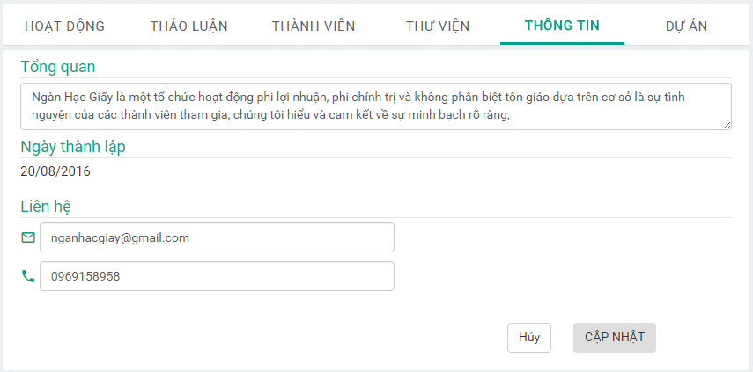

Figure 63: Edit group information.

## Join group request.

When Group leader receives request asking for joining the group from a registered user , Group leader can accept or deny request.

**Step 1**: Click on “THÀNH VIÊN” tab in group

**Step 2**: Click on “YÊU CẦU GIA NHẬP” tab.

**Step 3**: Click on “Đồng ý” icon button or “Từ chối” icon button.

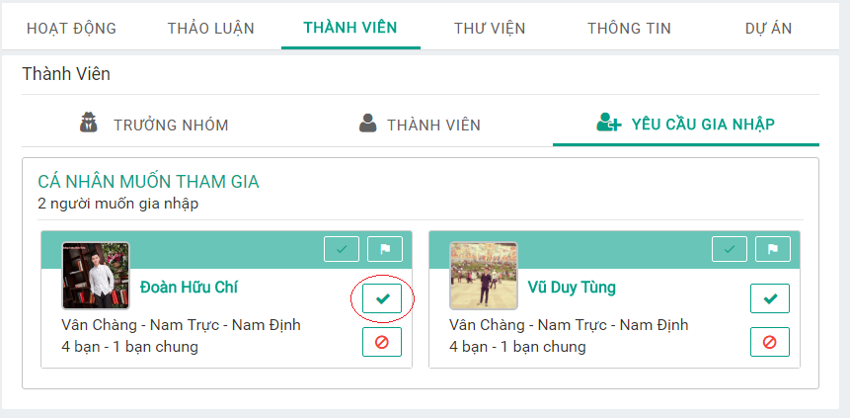

Figure 64: Accept request.

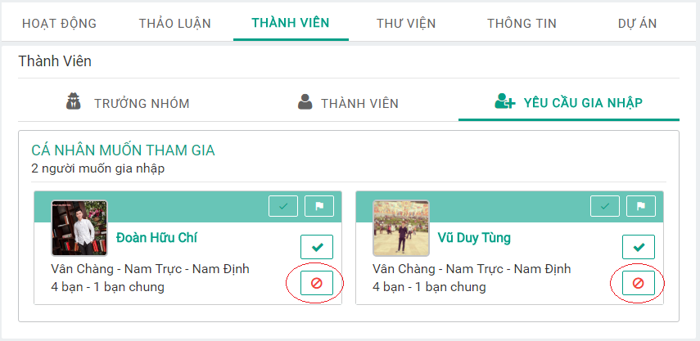

Figure 65: Deny request.

## Add friend to group.

Group leader can add friend to group.

**Step 1**: Click on “THÀNH VIÊN” tab.

**Step 2**: Click on “Thêm bạn bè” button. The system displays group leader’s friend list.

**Step 3**: Click on “XÁC NHẬN” button.

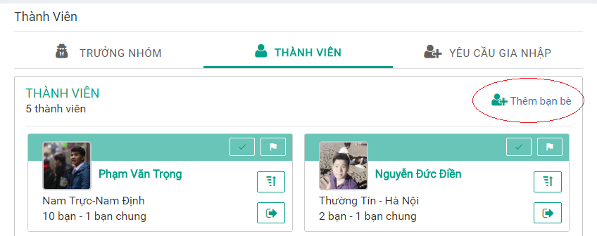

Figure 65: Add friend to group screen 1

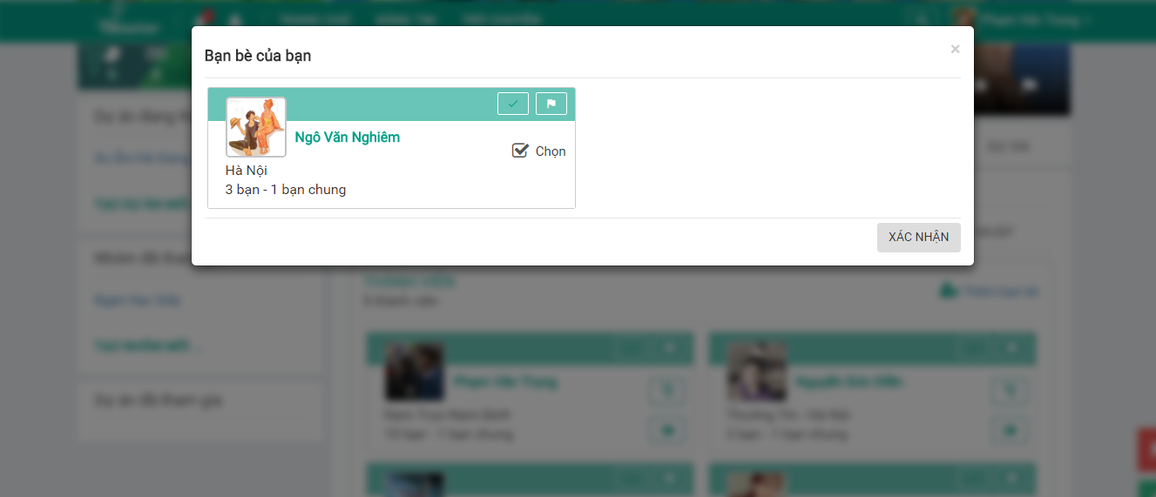

Figure 66: Add friend to group screen 2

## Assign Group leader.

Group leader can promote leader to member.

**Step 1**: Click on “THÀNH VIÊN” tab.

**Step 2**: Click on “Thăng chức” icon button.

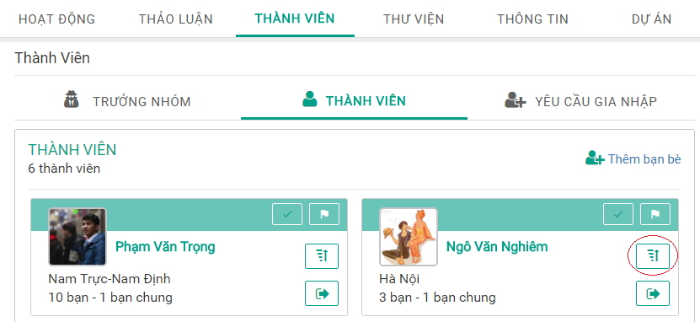

Figure 67: Promote leader.

Group leader can degrade leader.

**Step 1**: Click on “THÀNH VIÊN” tab.

**Step 2:** Click on “TRƯỞNG NHÓM” tab.

**Step 3:** Click on “Giáng chức” icon button.

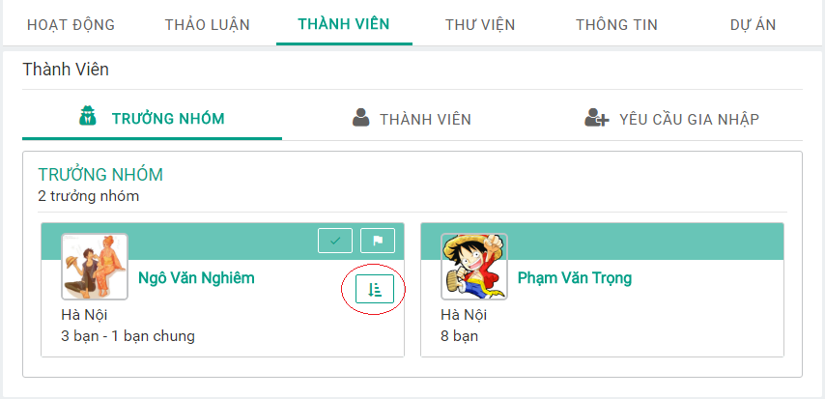

Figure 68: Degrade leader.

## Represent group to send join project.

Group leader can represent group to join project in the system.

**Step 1:** Click on project in the system.

**Step 2:** Click on “Đại diện nhóm” icon button. The system displays group leader’s group list.

**Step 3**: Click on “Đại diện nhóm tham gia” icon button.

**Step 4**: Select member who want to join project and Click on “HOÀN THÀNH” button.

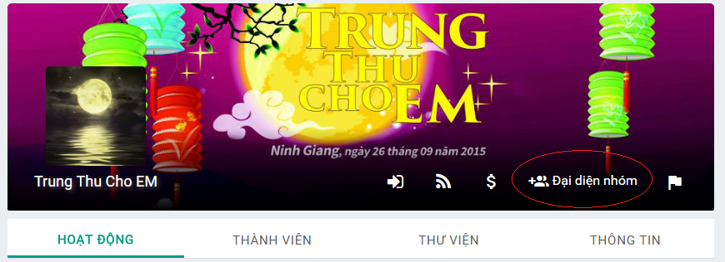

Figure 68: Represent group Screen 1.

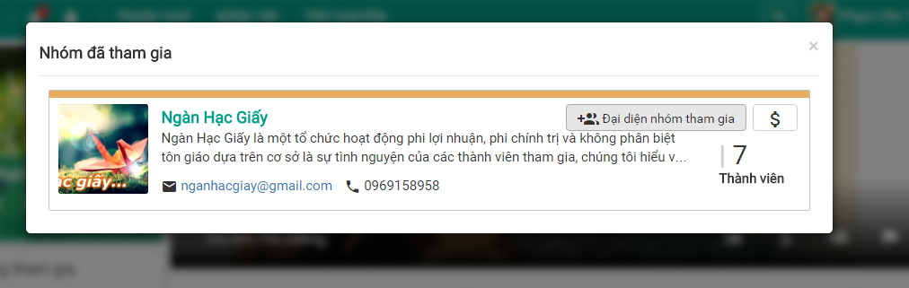

Figure 69: Represent group Screen 2.

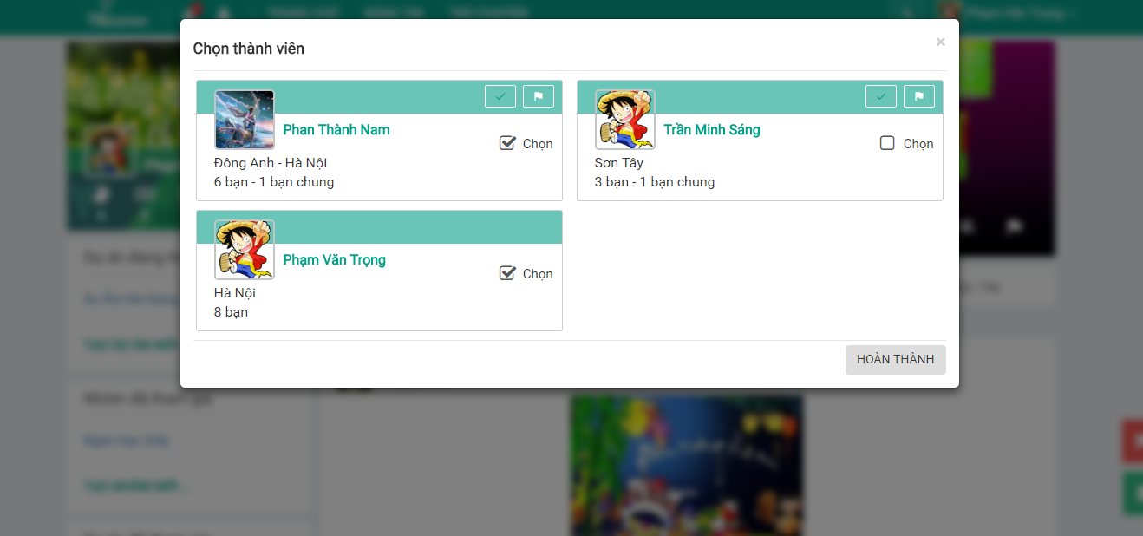

Figure 70: Represent group Screen 3

## Represent group to send donation project request.

Group leader can represent group to send donation request.

**Step 1**: Click on project in the system.

**Step 2:** Click on “Đại diện nhóm” icon button.

**Step 3**: Click on “Đại diện nhóm ủng hộ” icon button.

**Step 4**: Select member who want to donate for project and Click on “HOÀN THÀNH” button.

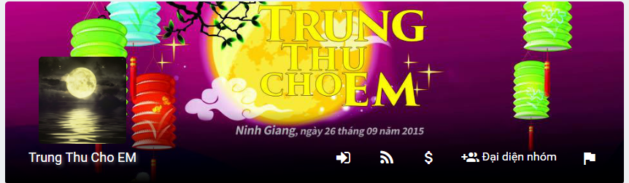

Figure 70: Represent group to send donate Screen 1

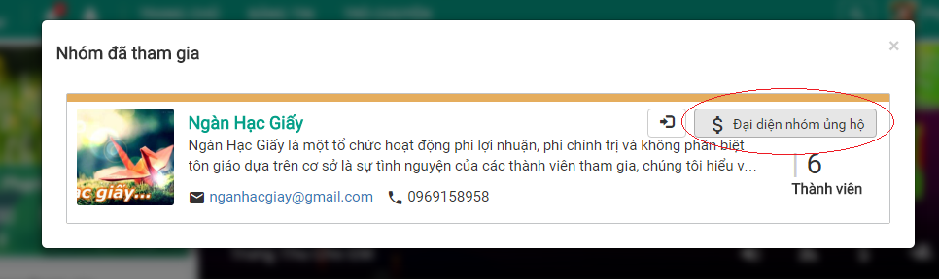

Figure 71: Represent group to send donate Screen 2

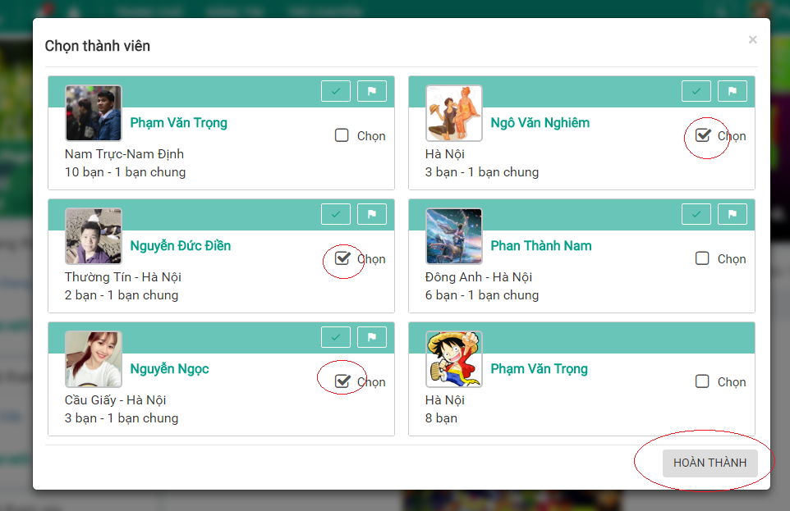

Figure 72: Represent group to send donate Screen 3

## Create Album.

Project leader, Group leader or member can create album in Project, Group.

**Step 1**: Click on “THƯ VIỆN” tab in project or group.

**Step 2**: Click on “TẠO BỘ ẢNH MỚI” link. The system displays album creation popup.

**Step 3**: Fill in form and Click on “TẠO ALBUM” button.

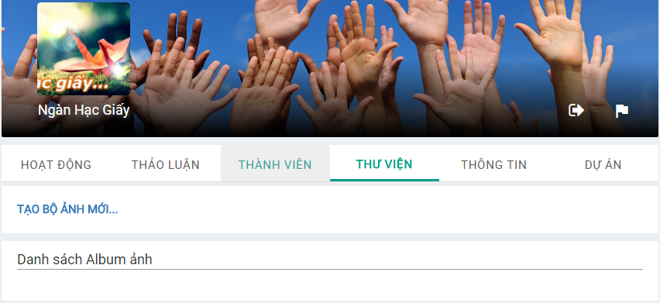

Figure 73: Create album Screen 1

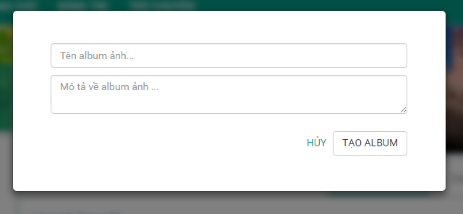

Figure 74: Create album Screen 2

## Add more photos to album.

Group leader, Project leader or member will add more photos to album.

**Step 1**: Click “THƯ VIỆN” tab.

**Step 2**: Click on “+” icon in album.

Step 3: Click “Thêm ảnh” button and choose photo(s). (Project leader, group leader, member can cancel upload photo by clicking on “Hủy bỏ” button.)

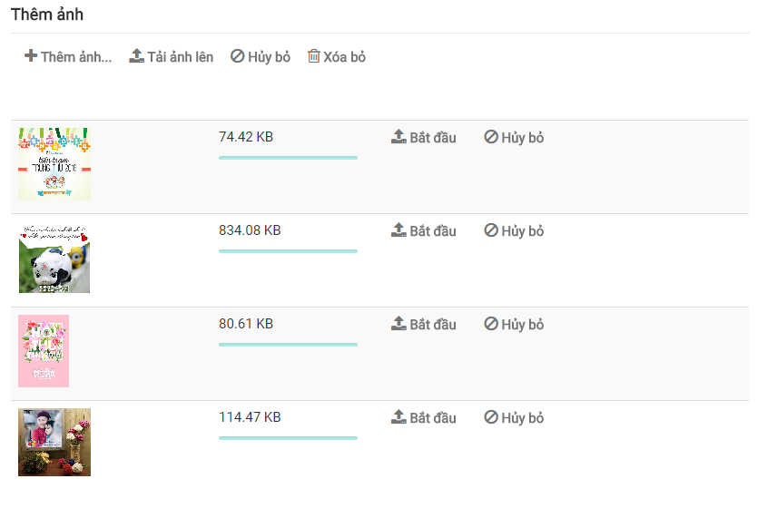

Figure 75: Add photo Screen 1

**Step 3**: Click “Tải ảnh lên” button or “Bắt đầu” button.

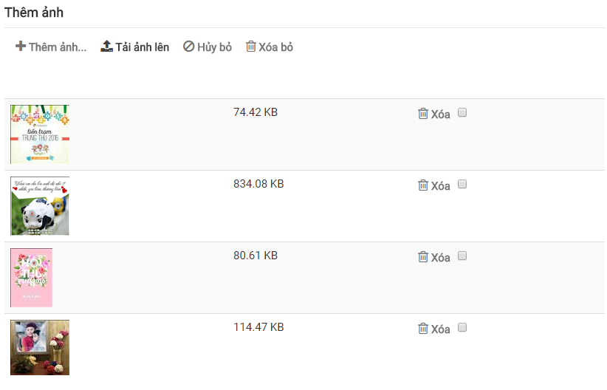

Figure 76: Add photo Screen 2

Project leader, Group leader or member can remove uploaded photo by clicking on “Xóa” button Or can remove all uploaded photos by :

**Step 1**: Tick on check box.

**Step 2**: Click on “Xóa bỏ” button.

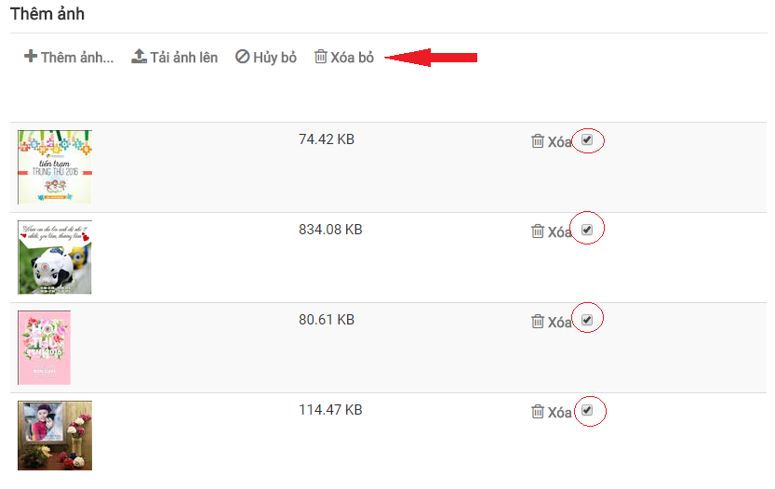

Figure 77: Remove all uploaded photos

## Post

Group leader or Project leader can create post in “HOẠT ĐỘNG” tab in Group or Project.

Group leader, Project leader or member can create post in “THẢO LUẬN” tab in group or project.

**Step 1**: Click on “your post” textbox, create post panel will be displayed

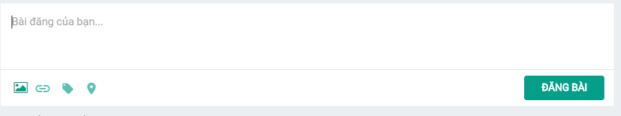

Figure 77: Create post

**Step 2**: Input text into “your post” textbox and Click on “ĐĂNG BÀI” button.

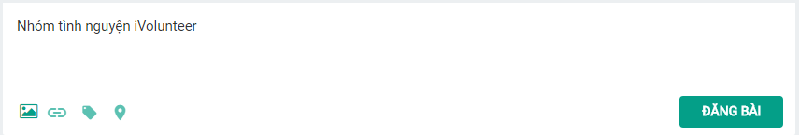

Figure 78: Create text post

**Step 3**: Input text into “your post” text box and Click on “image” icon button and choose photo. Then Click on “ĐĂNG BÀI” button.

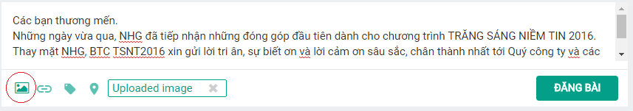

Figure 79: Create text and image post

Group leader, project leader can pin post by clicking “pin” icon button.

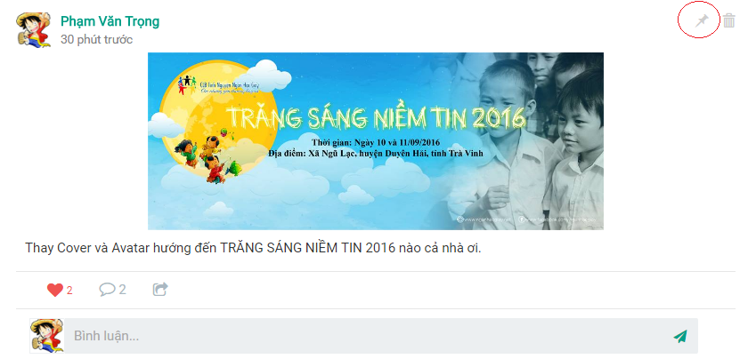

Figure 80: Pin post

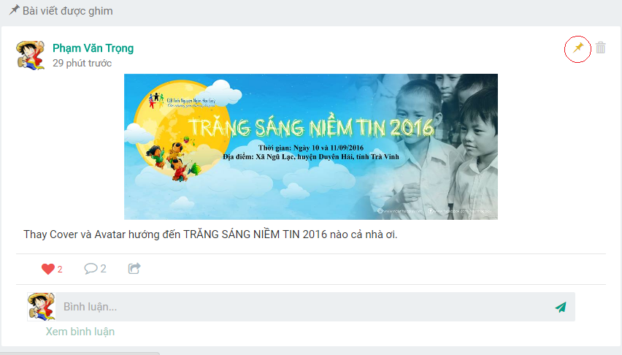

Figure 81: Unpin post

User can delete post by clicking “Delete” icon button in high-right of post.

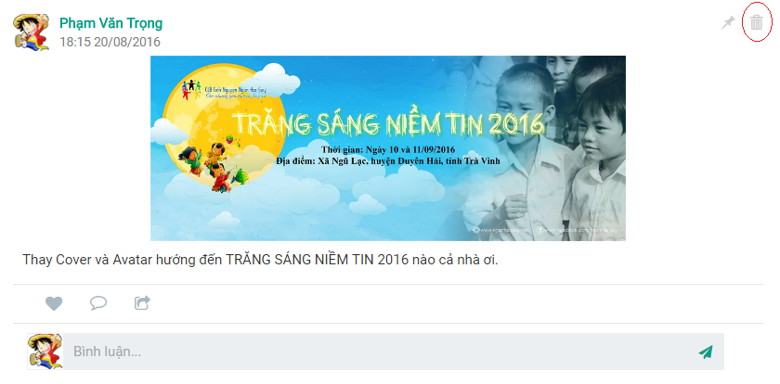

Figure 82: delete post.

Register user can comment on post

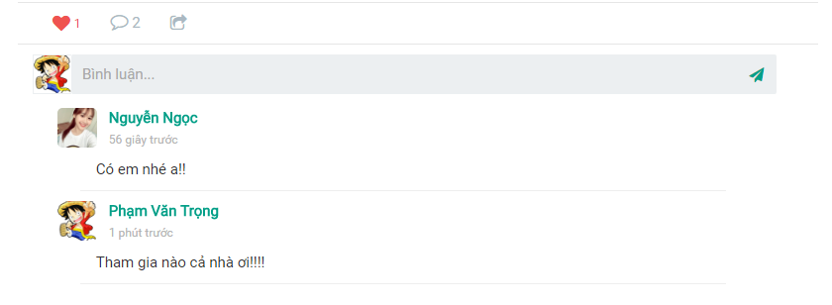

Figure 83: Comment.

Register user can delete comment by clicking on “delete” icon button in high-right of comment.

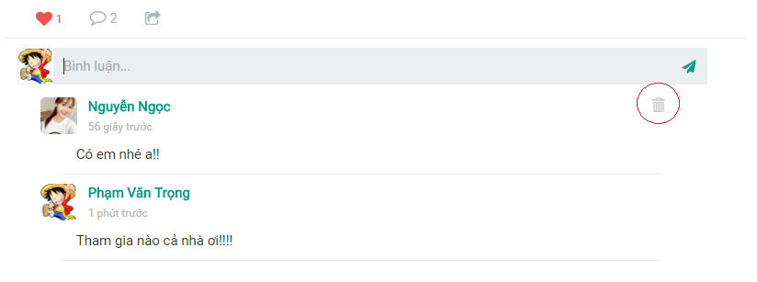

Figure 84: Comment.

Register user can like or unlike a post by clicking on heart icon.

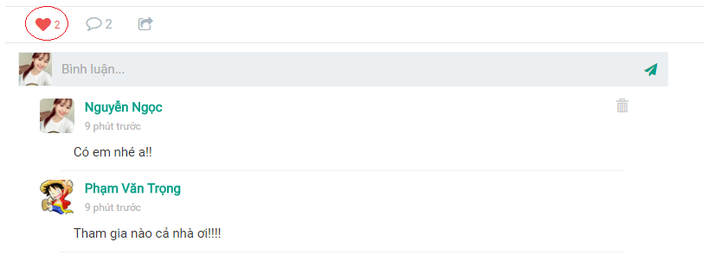

Figure 85: Like or Unlike post.

## Notifications

User will be inform by notifications on navigator bar when

* Friend request, Join group request, Join project request.
* Project leader promotion, Group leader promotion
* New post, comments for post
* Task assigned.

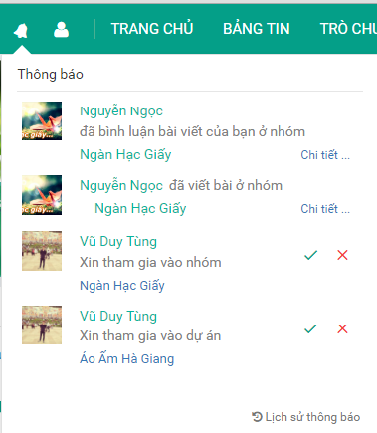

Figure 86: Notification

## Chat with friends

Registered user can start a conversation with a friend by clicking “TRÒ CHUYỆN” tab.

|  |  |
| --- | --- |
|  |  |
|  |  |

Figure 87: Chat Screen 1

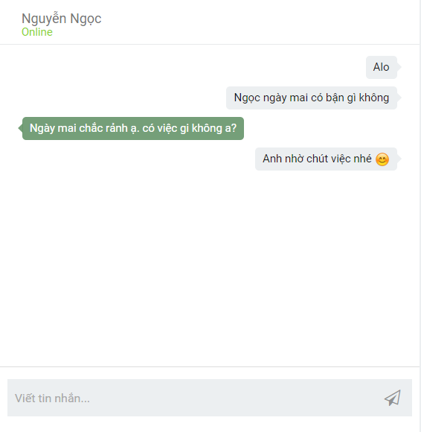

Figure 88: Chat Screen 2

## Report

Register can report a registered user.

**Step 1**: Click on registered user.

**Step 2**: Click on “Báo cáo vi phạm” icon button.

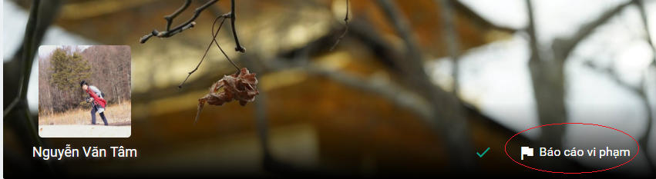

Figure 89: Report user.

Step 3: Input reason and click on “Báo cáo” button.

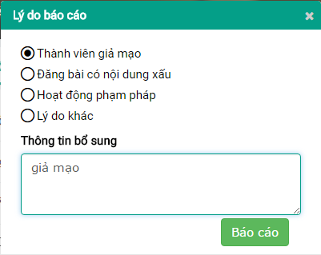

Figure 90: Report user.

Registered user can report project.

**Step 1**: Click on project.

**Step 2**: Click on “Báo cáo vi phạm” icon button.

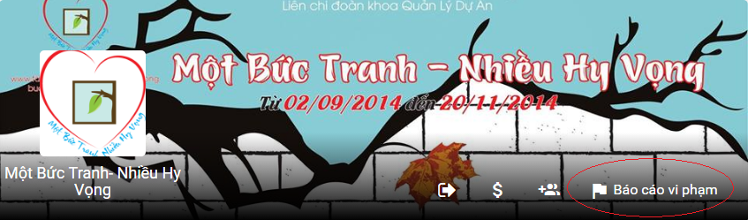

Figure 91: Report project.

Step 3: Input reason and Click on “Báo cáo” button.

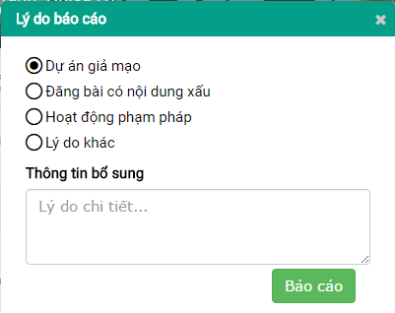

Figure 92: Report project.

Registered user can report group.

**Step 1**: Click on group.

**Step 2**: Click on “Báo cáo vi phạm” button.

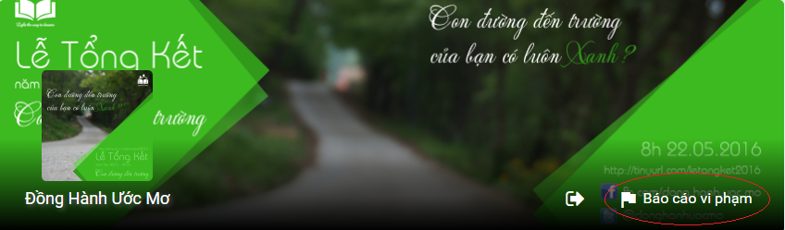

Figure 93: Report group.

Step 3: Input reason and Click “Báo cáo” button.

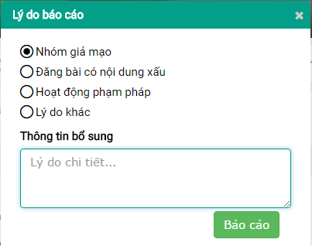

Figure 94: Report group.

Registered can cancel report by clicking on “Hủy báo cáo” button.

## Administration

Admin logins with administration account.

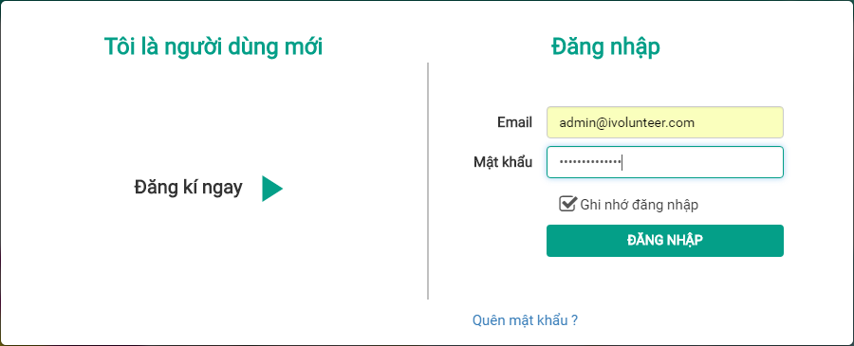

Figure 94: Login.

Admin can ban user or ignore user’s report.

**Step 1**: Click on “Danh sách báo cáo” tab.

**Step 2**: Click on “Thành viên vi phạm” tab to view reported user.

**Step 3**: Click on “Đình chỉ” button or “Bỏ qua” button.

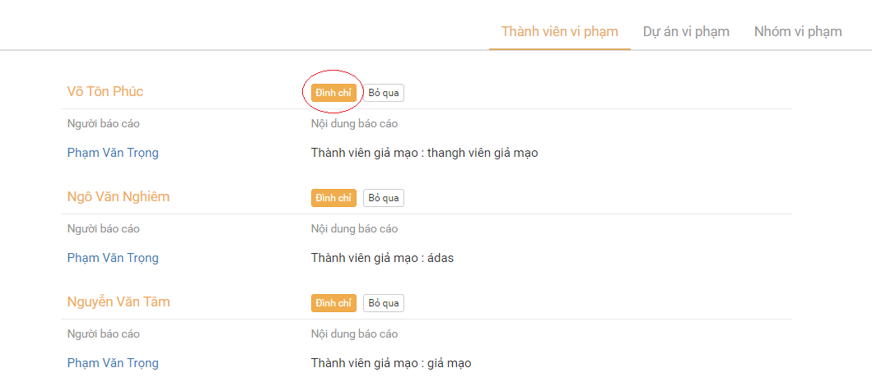

Figure 95: Ban user.

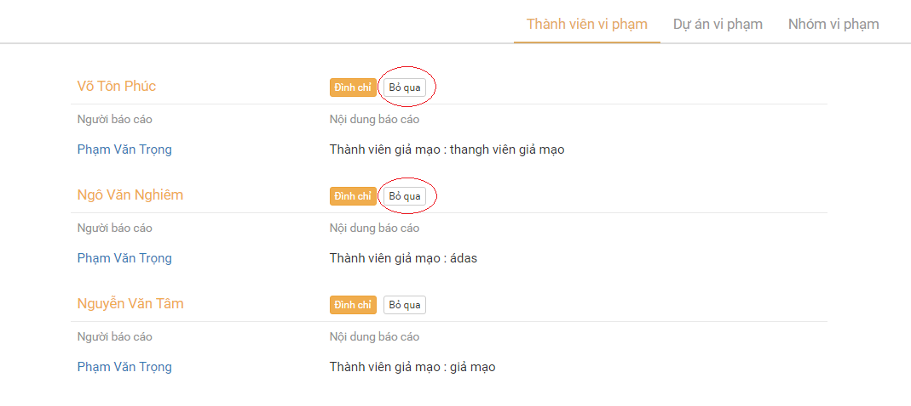

Figure 96: Ignore user’s report.

Admin can ban project or ignore Project’s reports.

**Step 1**: Click on “Danh sách báo cáo” tab.

**Step 2**: Click on “Dự án vi phạm” tab to view reported user.

**Step 3**: Click on “Đình chỉ” button or “Bỏ qua” button

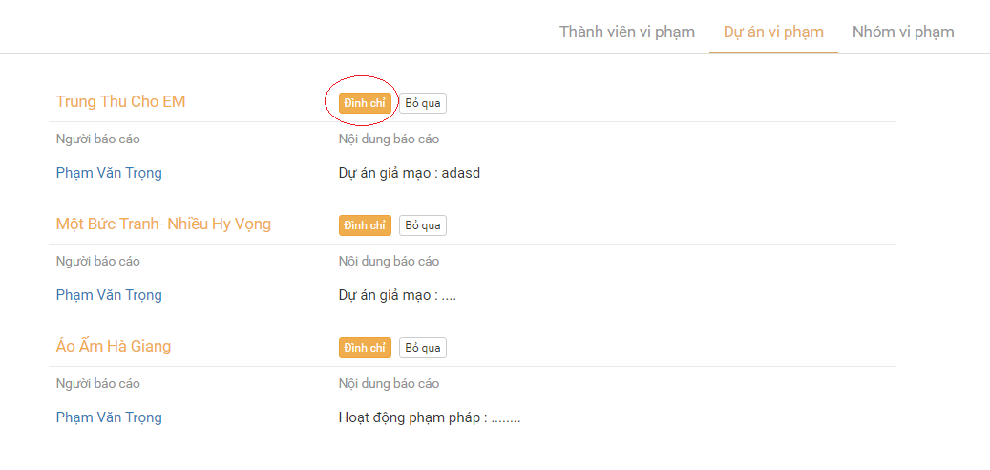

Figure 96 :Ban project.

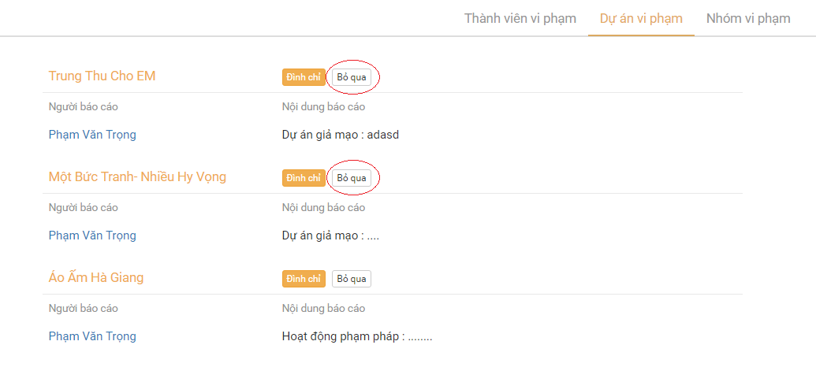

Figure 96: ignore project’s report.

Admin can ban project or ignore Group’s reports.

**Step 1**: Click on “Danh sách báo cáo” tab.

**Step 2**: Click on “Nhóm vi phạm” tab to view reported user.

**Step 3**: Click on “Đình chỉ” button or “Bỏ qua” button

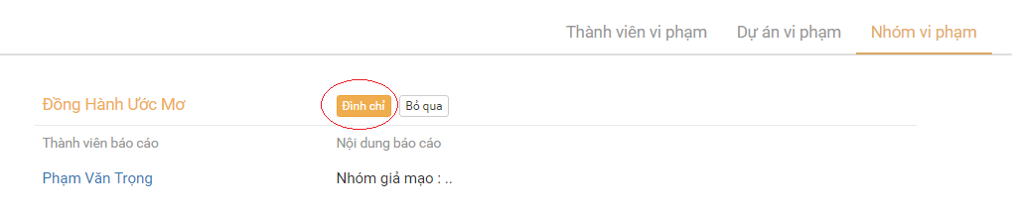

Figure 96: Ban group.

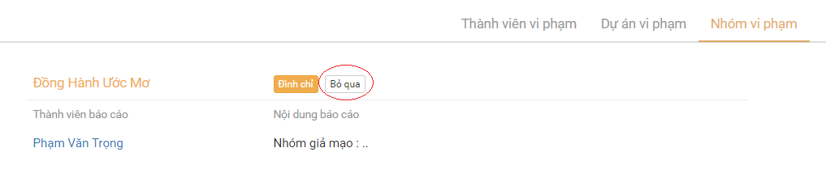

Figure 97: Ignore group’s report.

Admin can reactivate user, project or group by clicking on “Kích hoạt” button in “Danh sách đình chỉ” tab.

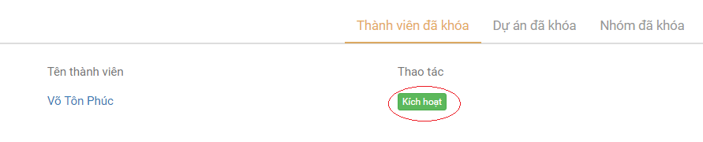

Figure 99: Reactivate user.

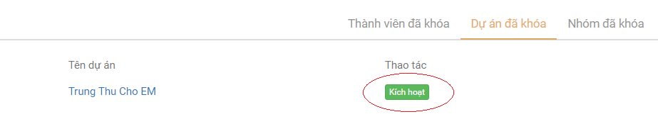

Figure 100: Reactivate project.

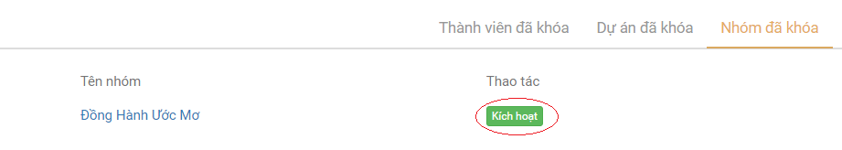

Figure 101: Reactivate Group.